BUNNELL BONNELL BUNNELL BONNELL BUNNELL BONNELL BUNNELL BONNELL BUNNELL B
UNNELL | THE BUNNELL/BONNELL NEWSLETTER |  |  |  | ONNE  L  L
B |  |  |  |  | B
O | Volume VI, No. 1. |  |  | 1 January 1992 | U
N  N  E  L  L |  | Published by  William R. Austin  P. O. Box 62  Laceyville, PA 18623  (717) 869-2325 |  |  | N  NE  L  L
BUNNELL BONNELL BUNNELL BONNELL BUNNELL BONNELL BUNNELL BONNELL BUNNELL B

CURRENT

¶ I have completed the every-name index to the first five years of the Newsletter. Copies are being sent with this issue to all the libraries on the mailing list and to all the individuals who have requested them. If you would like a copy, please let me know. The cost is $4.00.

¶ Clement M. Bonnell, III, called me to point out an error on page 46 of the last newsletter, Vol. V, No. 4. In the seventh line of the summarized article on HENRY BONNELL, 2d, I stated that Connecticut Farms, NJ, where Henry’s first wife was buried, is now known as New Providence. That is not correct. The community then known as Connecticut Farms, Essex co., NJ, is now Union, in Union co, NJ. Please note the correction on your copy. Thanks, Clem, for your help.

¶ William Bunnell, Concord, NH, obtained for me a copy of THE PICTORIAL HISTORY OF BUNNELL, FL, published in 19888 by The Pioneers of Bunnell to celebrate the 75th year since the incorporation of the town. I think it is an excellent example of its type–many, many pictures and interesting text filling 118 pages in a soft-cover binding. It is disappointing from our point of view that there is only a single reference to the Bunnell family for which the town was named: “Alvah A. Bunnell had established a cypress shingle mill near the railroad. To identify the stop for mail and to let off passengers it was called the Bunnell stop–thus it became known as Bunnell.” That is the only reference to anyone by the name of Bunnell. Bill Bunnell learned that they have about 50 copies left if any of you would like one. The cost is $15 plus $1.67 postage. They can be ordered from Mr. Otis Stone Hunter, Route 1, Box 28-A, Bunnell, FL 32010.

¶ Miss Jane Bell Morey, Concord, NH, sent me a number of newspaper clippings from local papers which mentioned various members of the Bunnell family. I wrote to several of the people mentioned and have had a very good response. Please watch for the Bunnell/Bonnell name in your newspapers and send the clippings in. You never know which one will lead to the solution of one of our tough problems.

* * * * * * *
??? BENJAMIN BUNNELL OF MIAMITOWN, OH ???

Several of my subscribers have been searching for the ancestry of the Benjamin Bunnell who was born in New Jersey in 1761 or 1762. He married HANNAH GOLDEN< who was born in 1758 in New Jersey. Several of their children were born in New Jersey, but some time after 1785 they removed to Hamilton Co, OH. Unfortunately, the census records for Hamilton co for 1800 and 1810 were lost. However, Benjamin appears in the tax lists for Miami twp, Hamilton co, in 1808 and 1810. By 1820 Benjamin “Bunnel” appears in the census in Whitewater twp, Hamilton co” 000101-00102. In 1830 he is still in Whitewater twp, as Benjamin “Bonnell”: 0000100001-000010001. He died at Miamitown, Hamilton co, and was buried in the Miami Cemetery at Miamitown. His gravestone reads: “BENJ. BUNNELL Died Oct. 30, 1847. In the 86th year of his age.”

Children:
- Sarah, b. 19 Jan. 1788, Essex co, NJ; m. 1808, Hamilton co, OH, James Ireland.
- Mary, b. 6 Oct. 1789, NJ; m. Jacob Coleman.
- Isaac, b. about 1795 (see insert below +++)
- Daniel, b. 21 (or 2) Nov. 1795, NJ.
- Catherine, b. 16 Feb. 1801 (or 2 Apr. 1802).
- Hannah, b. 19 Dec. 1802; m. Abraham Ireland.
- Benjamin, b. 1804, OH.
- Elizabeth.

The 1820 census record was sent to me by Shirley Stone, the 1820 and 1830 records by Mrs. Harry Atleson, while the Miami twp tax data and the 1820 and 1830 census records are found in the CB Database. A recent photograph of Benjamin’s gravestone was sent to me by Dorothy Hanaway. All other data in the above account (except the reference to son Isaac) was submitted by Benjamin’s descendants, Lynn Arnold, Charleene Ireland-Harmon, and Vera Reeve. Data on the families of Sarah and Mary came from PORTRAIT AND BIOGRAPHICAL SKETCHES OF THE WILLAMETTE VALLEY, OR, and HISTORY OF CINCINNATI AND HAMILTON COUNTY. Much of the information was gathered years ago by Emma Arnold and Delight Kerr.

++++++++++++++++++++++++++++++++++++++++++++++++++++++++++++++++
+ On page 958 of the HISTORY OF CINCINNATI AND HAMILTON COUNTY is +
+ an article about Andrew J. Bunnell, born in Whitewater twp in 1825, son of ISAAC +
+ and Sarah (Fauver) Bunnell, both natives of New Jersey. The father came to +
+ Hamilton county, Ohio, from New Jersey, when only about three years old, and +
+ about 1830 located in Miami township and worked at farming for a few years; then +
+ removed to Taylor’s Creek, where he was engaged in the milling business and +
+ carried on a general store up to the time of his death. We have been searching for +
+ Isaac’s parents for many years, but as a result of this review, I believe there can be +
+ doubt that Isaac was the son of Benjamin and Hannah (Golden) Bunnell. +
++++++++++++++++++++++++++++++++++++++++++++++++++++++++++++++++
Benjamin Bunnell (Cont’d)

The early researchers concluded that this Benjamin was the same as the Benjamin Bonnell, Jr., who married Hannah Ward, and that Hannah Golden was his second wife. This was not correct. Benjamin Bonnell, Jr., son of Benjamin and Rachel (Van Winkle) Bonnell, died 9 October 1808 in Springfield twp, Essex (now Union) co, NJ, at the age of 57 years, 7 months and 5 days. This puts his birth year at 1751, ten years earlier than our subject. He married Hannah Ward, who survived him and married (second) in 1810 Elder Moses Miller. This Benjamin lived all his life in New Jersey. He was buried in Chatham, Morris co, NJ.

Who , then, were the parents of Benjamin Bunnell, 1761-1847? There are at least two possibilities, depending on whether he was actually Benjamin, Jr., or not. Was he called Jr. by the early researchers because they identified him with the other Benjamin who was a junior? Or did they know from family records or traditions that his father’s name was also Benjamin, and the Benjamin who married Hannah Ward was the only Benjamin, Jr., they could find?

Let me list several pieces of stray data:
- The Hatfield Family Bible states that Aaron Bonnell was born 30 March 1749 in New Jersey, the son of Benjamin and Eleanor Bonnell.
- Aaron was married in Mendham twp, Morris co, NJ, in 1772. One of the bondsmen for his marriage was Benjamin Bonnell.
- Benjamin Bunnel, householder, with 8 acres of land and 1 horse, exempt from military service, was listed in the tax list in Mendham twp, Morris co, NJ, in June 1778. He does not appear in the list in Mendham in June 1780.
- Benjn Buneel with 2/3 of a gristmill was listed in the tax list of Hanover twp, Morris co, NJ, in Feb. 1780 (but not in 1778). In the same list was a John Bunnel who had 1/3 of a gristmill. Was he Benjamin’s partner?
- The 1793 census of New Jersey men eligible for service in the militia lists Benjn. Bonnell, Jr., in Essex co., and Benj. Bunnell in Morris twp., Morris co, NJ.
- The will of Thomas Bonnell of Hanover twp, Morris co, NJ, dated 23 January 1788, was probated 11 May 1790 and mentions among others a son Benjamin.

Now let’s examine the two possibilities:

First: If Benjamin was not known to have been a Jr., he could have been the son who was mentioned in the will of Thomas Bonnell of Hanover twp. He would certainly have been too young to have been the householder in Mendham twp in 1778, but Benjamin Bunnell or Bonnel or Bonnal continues to appear in the Hanover twp tax lists in 1781, 1783, 1785, 1786, 1787, 1789, 1790. 1791, 1792, 1793 and 1795. He would probably have been the militiaman of 1793. After 1795 Benjamin does not appear in the tax lists, which continue until 1822. This would seem to fit with the move to Ohio sometime after 1795.
Benjamin Bunnell (Concl’d)

It should be noted that Paul J. Bunnell, in his book THUNDER OVER NEW ENGLAND, has suggested that Benjamin, the son of Thomas of Hanover, was the Benjamin Bonnell, Loyalist, who served in the British army in the Revolution and who emigrated to New Brunswick, Canada, in 1783. If so, he could not have been the Benjamin who appears in the tax and militia records in the 1790’s. I am not aware of any evidence to support this relationship except that Thomas of Hanover had a daughter named Affa and Benjamin of New Brunswick named a daughter Alphia.

Second: If Benjamin was known to have been a Jr., he may well have been another son of Benjamin and Eleanor Bonnell. If so, he would have been 12 or 13 years younger than his brother Aaron (which suggests that Benjamin and Eleanor might also have been the parents of some of the other unattached Bonnells of that period).

The Benjamin Bunnell in Mendham in 1778 was probably the father of Aaron, and he may have been the Benjamin who appears in the Hanover twp tax lists until 1795. However, note that in the tax list of July 1785 he is listed as Benjamin Bonnal, Jr., the only time he is so recorded. It seems likely, or at least possible, that the later references are to the younger Benjamin who married Hannah Golden.

The Benjamin who was listed in the Morris co militia in 1793 could not have been the elder Benjamin, since he was old enough to be exempt from militia duty as early as 1778. Likewise, it could not have been the Loyalist Benjamin wince he had left the country ten years before. I suggest that it was Hannah Golden’s husband. He was not called Benjamin, Jr., in the list, and probably the elder Benjamin had died some time before. Note that the husband of Hannah Ward was specifically listed as Benjamin, Jr., in the Essex co militia in 1793, since his father was still living.

It is important to recognize that all this is merely guesswork on my part. However, I believe it suggests possibilities which warrant intensive investigation. It provides a focus for the research of Benjamin’s descendants. Questions which need answers include:

- Was Benjamin known to be a Jr. before he was erroneously identified with the Benjamin, Jr. of Essex co?
- Who were Hannah Golden’s parents and where did they live? In Morris co? Did her father or mother leave a will?
- Do the land records of Morris co identify the particular property owned by the senior Benjamin, and is there any indication that the younger Benjamin acquired the same property?
- Is there a deed which shows the sale of property in Morris co by Benjamin and Hannah when they left for Oho? It would be between 1795 and 1800.
- Is there a deed which shows the sale of property in Morris co by Benjamin and Hannah when they left for Ohio? It would be between 1795 and 1800.
- Is there a probate record following the death of the senior Benjamin?

If anyone can throw any further light on this relationship, either positively or negatively, please let me know. Our success in establishing the parentage of Miles Bunnell in this way encourages me to hope for the best in this case..
* * * * * * *
DOES ANYONE KNOW THIS MAN?

Louise Nemecek, Richmond, VA, wrote to me in August asking for help in identifying the ancestry of her grandfather FRANKLIN BUNNELL. Claude Bunnell was once again able to pull the necessary information out of his Database, along with data from a Family Group Sheet sent to me by Paula Bonnell Sacco in 1987.

Louise found an old glass over wood photo among her father’s effects, which may be that of her great grandfather, Samuel Bonnell. She had a copy made for the Newsletter, and the photo studio thinks the picture was originally taken in the 1870’s. If the photo was indeed one of her direct Bonnell ancestors, it would have to be of Samuel, who was born in 1839. Samuel’s father was in his 70’s at the time, and his son Franklin was in his teens. Samuel appears in the 1850 census in District 21, Harrison co, WV, and in the 1880 census in Center twp, Chautauqua co, KS. The picture was probably taken in Kansas. Can anyone tell us definitely whether or not this is a picture of Samuel Bonnell?
The lineage is as follows:
William Bunnell CB260001
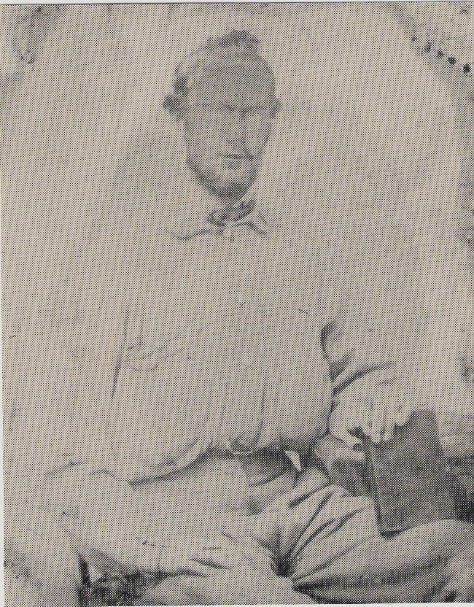[Type a quote from the document or the summary of an interesting point. You can position the text box anywhere in the document. Use the Drawing Tools tab to change the formatting of the pull quote text box.]
Nathan Bonnell CB270005
Isaac Bonnell CB2800014
Abraham Bonnell CB290024
John Bonnell CB310033
Jonathan Bonnell CB320937
SAMUEL BONNELL CB331594
Franklin Bunnell CB006412
Frederick Hartsock Bunnell CB001004
Louise Brander (Bunnell) Nemecek

* * * * * * *

More strays–Can anyone identify them?

- Several years ago Edward G. Skinner, Emporium, PA, in exchange for some help I had given him on his Skinner ancestry, checked the Cameron co, PA, Hall of Records and found that in October 1891, in Cameron co, FRANK S. BUNNELL, born in 1859 in Crawford co, PA, married CARRIE S. PEPPER, born in 1861 in New York State.

- A clipping from the Spokane, WA, Daily Chronicle in 1961: “Dr. HARRIS F. BUNNELL named Superintendent of Eastern State Hospital, Medical Lake, Wash. Bunnell, 47, has a long history of private and public medical and psychiatric practice. A native of Toppenish, Wash., he is married and has three daughters.”
* * * * * * *

Names on the Land

In Volume III, No. 3, of the Newsletter I printed an account of the life of George William Bonnell, for whom Mount Bonnell in Austin, TX, was named. Gwen Quickel, Lake Jackson, TX, sent me an article which appeared in a Texas newspaper last June describing the beauties of Mount Bonnell and its associated park. Although the article makes no mention of how the spot got its name, I thought you might be interested in what is there and how to get there. I have abridged the article slightly and deleted the pictures for lack of space.

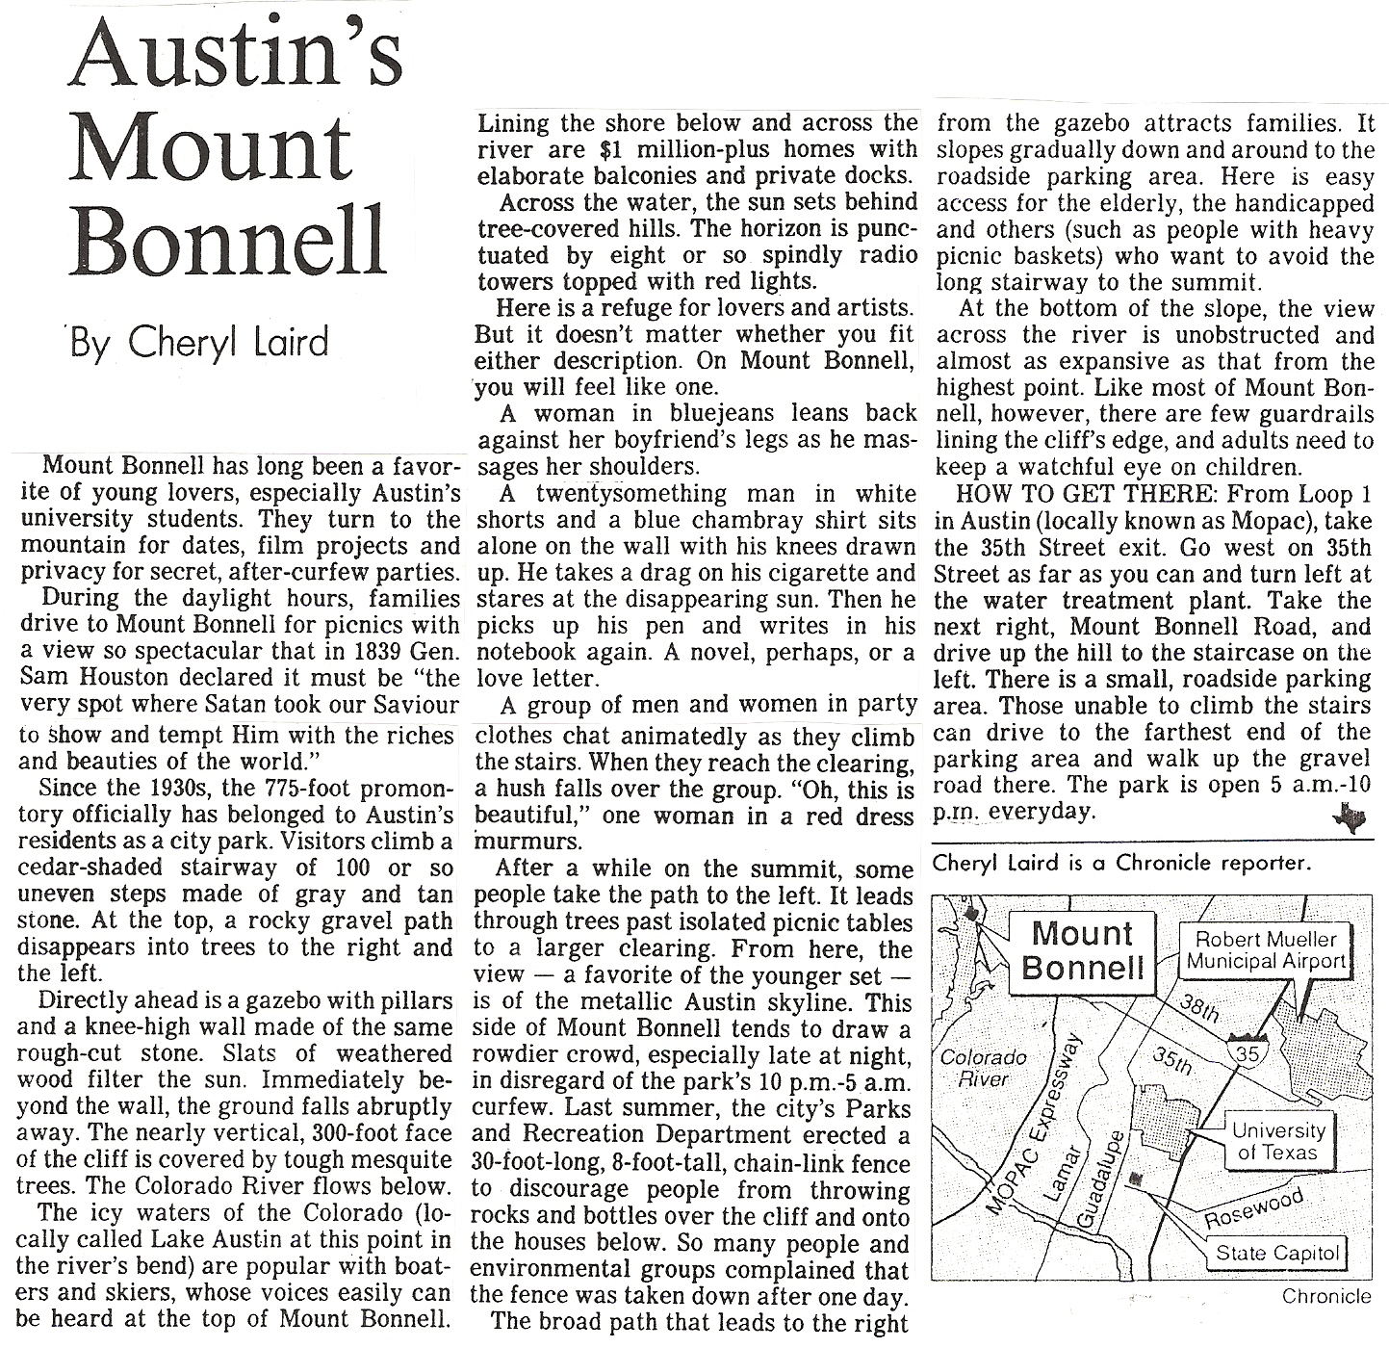

* * * * * * *
MILESTONES

This obituary was submitted by Miss Jane Bell Morey, Concord, NH. It appeared in the Manchester, NH, UNION LEADER, 16 September 1991. For the sake of space I have extracted only relevant parts of the obituary.

WALTER T. PIERCE

RINDGE–Walter T. Pierce, 67, of Monadnock Park, died Sept. 15, 1991, in his home after a lengthy illness.
Born in Ashburnham, Mass., he lived for a time on Plum Island, Mass., and resided the past 13 years in Rindge.
…
In addition, he was a communicant of St. Patrick Church, Jaffrey.
Family members include his wife of 19 years, Clarice (Girardin) Pierce, of Rindge; two sons, Ted Pierce, of Tampa, Fla., and John Pierce, of Newburyport, Mass.; a daughter, Kathleen Georgilis, of Newburyport, Mass.; two stepsons, Paul R. Bunnell, of Gurnee, Ill., and Bunnell, of Orange, Mass.; nine grandchildren; …
…
Burial will be in Glenwood Cemetery, Ashby, Mass.

[Miss Donna Bunnell, Orange, MA, answered my letter and has promised to send me additional data on the family.]

* * * * * * *

Miss Morey also sent in this clipping from the Manchester UNION LEADER of 26 May 1989:

BIRTHS–ELLIOT HOSPITAL

A daughter was born to Mr. And Mrs. Gary Bunnell of 40 Tandreau Court, May 19.

[A letter of inquiry to Gary Bunnell brought me this response from his wife Diane: “My husband Gary Bunnell is originally from Berlin, New Hampshire. He is the son of Merle and Juliette Bunnell also of Berlin, New Hampshire. Merle is the son of Jessee Bunnell also of Berlin/Milan are of New Hampshire.” I have not been able to identify this Jesse. Any ideas?

* * * * * * *

This obituary appeared in the NEW AGE-EXAMINER, Tunkhannock, PA, Friday, 20 September 1991:

THELMA B. HEITSMAN

Thelma B. Heitsman, RD 1, Box 12, Springville, died unexpectedly Sunday, Sept. 15, 1991, at Robert Packer Hospital, Sayre. She was the wife of Robert S. Heitsman.
Born in Montrose, daughter of the late Webb and Leah Stockholm Bunnell, she attended the Springville Baptist Church.
Also surviving are a daughter, Barbara A. Bradt, Apalachin, N.Y.; five grandchildren; nieces and nephews.
She was preceded in death by a son, Robert W. Heitsman.
Obituary, Thelma B. Heitsman (Concl’d)

The funeral was held Wednesday with services in the Springville Baptist Church by the Rev. Drue G. Corbett.
Internment, Dimock Cemetery.
Memorial contributions may be made to the Springville Baptist Church or the donor’s favorite charity.

[Mrs. Heitsman’s descent from Benjamin CB300045 and Catherine (Barry) Bunnell runs through their son Gershom CB310262 and Sarah (Kellogg), Jonathan CB320401 and Charlotte E. (Fargo), Gersham W. CB331148 and Mary Adeline (Sharpe), and Webb E. CB341328 and Leah Grace (Stockholm).]

* * * * * * *

In the last issue, I printed the obituary of Letha Bunnell, widow of Rupert, asking if anyone could identify Rupert Bunnell. Joan Murray searched out Rupert’s own obituary which appeared in the Elgin, IL, COURIER, 23 May 1986:

RUPERT BUNNELL–BATAVIA

Rupert Bunnell, 68, of The Holmstad, Batavia, formerly of Elgin, died Thursday, May 22, at Mercy Hospital, Aurora.
He was born April 19, 1918, in Elgin, the son of George and Pearl Hall Bunnell.
He was employed with the Shakeproof Division of Illinois Tool Works Inc. for 28 years and was a member of Elgin Bible Church.
Surviving are his wife, Letha; a son James (Debbie) of Elgin; a granddaughter, Jennifer-Lee of Elgin; a sister, Frances Hartung of Lombard; and a brother, Robert Bunnell of California.
Besides his parents, he was preceded in death by a brother.
Services will be at 1 p.m. Saturday in Schmidt-Madison Funeral Home, Elgin, the Rev. David Hornok officiating. Burial will be in Memorial Estates Cemetery, Northlake.

[Rupert’s father, George Harley Bunnell CB007723 was the son of Robert Franklin CB330854, son of Alfred CB320647, son of Moses Atwater CB310025, son of Abner VB300041, son of Abner CB290021, son of Nathaniel CB280011, son of Benjamin CB270004, son of William CB260001, the immigrant. Alfred Bunnell CB320647 is #301 in Ruth Duncan’s book, WILLIAM BUNNELL AND HIS DESCENDANTS.]

* * * * * * *

The next one was submitted by Jack Mowry, Northeast, PA. It appeared in the Erie, PA, Times, 3 July 1991.

GENEVIEVE MARTIN BONNELL, 77, 104 Old Niagra Road, Lockport N.Y., formerly of Albion, died Tuesday, July 2, 1991, at the Lockport Odd Fellows and Rebekah Nursing Home.
She was born June 25, 1914 in Elkcreek Twp., Erie County, daughter of the late Charles and Nina Brock Martin.
She worked as a beautician in Edinboro and Cambridge Springs, but mostly in the Albion area. She was a past member of the Wellsburg United Methodist Church in Albion.
She was preceded in death by a sister, Leona Merchant.
Survivors include tow daughters, Mrs. Carl (Marlene Kingen)
Obituary, Genevieve Martin Bonnell (Concl’d)

Minzenberger of Erie and Mrs. Leon (Kay Kingen) Thompson of Burt, N.Y.; three sons, Gary Kingen of Edinboro, Dale Bonnell of Venango and Dennis Bonnell of Albion; a brother, Leslie Martin of Indiana; 11 grandchildren; and one great-grandson.
Friends may call at the Harry D. Glunt Funeral Home, 2010 Erie, Edinboro, on Thursday from 7 to 9 p.m. and Friday from 2 to 4 and 7 to 9 p.m. Services will be there Saturday at 11 a.m. with the Rev. John Margargee officiating.
Burial will be at Hope Cemetery.
Memorials may be made to the Albion Volunteer Fire Department.

[Can anyone provide more information about this Bonnell family? Albion, Elkcreek twp, Edinboro, and Erie are in Erie co, PA. Cambridge Springs and Venango are in Crawford co, PA, and Indiana is in Indiana co, PA.

* * * * * * *

And finally, an obituary submitted by Ruth Duncan, West Simsbury, CT.

CAMILLE F. BUNNELL, 74

NEW HAVEN–Camille Ferraro Bunnell, 74, of 315 Eastern St., died Tuesday, Nov. 5, 1991, at New Fairfield Hall Care Center after a long time illness. She was the wife of Karl S. Bunnell.
Mrs. Bunnell, daughter of the late Gerard and Mary Ferraro, was born in New Haven July 12, 1917, and lived in West Haven before moving to New Haven 11 years ago.
Besides her husband, she leaves a daughter, Linda Deloye of Waterbury; two sons Martin Bunnell of Sunnyvale, Calif., and Francis Giammattei, both of West Haven; four brothers, John Ferraro of Cheshire, Joseph Ferraro of North Branford, Rocco Ferraro of Orange and Ted Ferraro of West Haven; nine grandchildren; and three great=grandchildren.
The funeral will leave the Keenan Funeral Home, 238 Elm St., West Haven, Thursday at 9:30 a.m. A Mass of Christian burial will be celebrated at 10 at Our Lady of Victory Church. Burial will be in All Saints Cemetery, North Haven.

[Earl Solomon Bunnell CB360411 is #951 in Ruth Duncan’s book WILLIAM BUNNELL AND HIS DESCENDANTS. Earl’s descent is as follows:
William CB260001 and Ann (Wilmot) Bunnell
Benjamin CB270004 and Rebecca (Mallory) Bunnell
Benjamin CB290006 and Hannah (Plumb) Bunnell
Benjamin CB290003 and Mehitable (Baldwin) Bunnell
Isaac CB300006 and Ann (Collins) Bunnell
William CB310003 and Sarah (Dorman) Bunnell
Sheldon CB320597 and Anna (Morehouse) Bunnell
John Maxson CB331087 and Julia E. (Loveland) Bunnell
Myron Edward CB341231 and Lottie Estelle (Lee) Bunnell
Roy Irving CB351183 and Viola Agnes (Grubb) Bonnell
Earl Solomon Bunnell

* * * * * * *
INTERNATIONAL GENEALOGICAL INDEX

CONNECTICUT–1988 Update Submitted by Jerry Hatch

[Fairfield county–1666, Original county)

Fairfield county–Births:
Bunnell, George L. Henry Bunnel/Abigail Williams Munson M 22 Jan 1867

Fairfield, Fairfield county–Marriages:

Bunnell, Giles Abigail Ogden 10 Oct 1825

Greenwich, Fairfield county–Marriages:

Bunnell, Sabrina William Bowen 24 Dec 1845

Newton, Fairfield county–Births:

Bunnell, Bradley Job Bunnell/Rachel M 26 Jan 1784
Bunnell, Hannah Nathaniel Bunnell/Sarah F 09 Feb 1773
Bunnill, Hannah Nathaniel Bunnill/Sarah F 09 Feb 1773
Bunnell, Hannah Job Bunnell/Rachel F 04 Jul 1773
Bunnell, Hannah Job Bunnell/Rachel F 10 Jun 1776
Bunnell, Nathaniel Nathaniel Bunnell/Sarah M 07 Dec 1769
Bunnill, Nathaniel Nathaniel Bunnill/Sarah M 07 Dec 1769
Bunnell, Stephen Job Bunnell/Rachel M 22 Nov 1778
Bunnill, Patience Nathaniel Bunnill/Sarah F 12 Jul 1775
Bunnell, Patience Nathaniel Bunnell/Sarah F 12 Jul 1775

Newton, Fairfield county–Marriages:

Bunnell, Job Rachel Bradley 10 Sep 1772
Bunnell, Nathaniel Sarah Persons 18 Sep 1768
Bunnell, Nathaniel Sarah Parsons 18 Sep 1768

Redding, Fairfield county–Births:

Bunnell, Isaac Isaac Bunnell/Jerusha Sherwood M 1781

Redding, Fairfield county–Christenings:

Bunnell, Isaac Gershom Bonnell/Margaret Johnson M 21 Jul 1745

Stamford, Fairfield county–Births:

Bunnel, Elizabeth Benjamin Bunnel/Mercy Green F 20 Jul 1731
Bunell, Elizabeth Benjamin Bunell/Mercy F 20 Jul 1731
Bunnel, Mary Demill /Susannah Bunnel F 12 Jan 1756
Bunnel, Samuel Benjamin Bunnel/Mercy Green M 19 Jan 1728
Bunnell, Samuell Benjamin Bunnell/Mercy M 19 Jan 1728
Bunnell, Susana Benjamin Bunnell/Mercy F 15 Feb 1726
Bunnel, Susanna Benjamin Bunnel/Mercy Green F 15 Feb 1726
Stamford, Fairfield county–Marriages:

Bunnell, Benjamin Mercy Green 01 Oct 1723
Bunnel, Benjamin Marcy Green 02 Oct 1723

Stratford, Fairfield county–Marriages:

Bunnell, Gershom Margaret Johnson 01 Jan 1728

Westport, Fairfield countyz-Marriages:

Bunnell, Elizabeth B. John C. Collins 03 Jul 1844

[Hartford county, 1666, Original county]

Berlin, Hartford county–Marriages:

Bunnel, Catharine Luther Graham 15 May 1831
Bunnell, Lucy Nelson Sperry 31 Jul 1822

Bristol, Hartford county–Births:

Bunnell, Bela Jesse Bunnell/Mehitable Royce or Rice M 27 Aug 1765*
Bunnell, Bela Vinson Bela Bunnell/Ruth McDuffee M 1811
Bunwell, Levi Jesse Bunwell, Mehitabel Royce M 21 Dec 1777
Bunwell, Mehitabel Jesse Bunwell/Mehitabel Royce F 17 Oct 1773
Bunwell, Seth Jesse Bunwell/Mehitabel Royce M 09 Dec 1770

* See also Farmington, Hartford county.

Bristol, Hartford county–Marriages:

Bunnell, Allen Rhoda Atwater 08 Feb 1826
Bunnell, Charlottee Norman Allen 13 May 1844
Bunnel, Jane Ellen James E. Merriam 09 Mar 1851
Bunnell, Susan David B. Cark 31 Oct 1833

Burlington, Hartford county–Marriages:

Bunnel, Daniel Dolly Hill 19 Apr 1841
Bunnel, Enos Matilda Moses 24 May 1837

Farmington, Hartford county–Births:

Bunnell, Abel Jesse Bunnell/ M 1758
Bunel, Abel Jesse Bunnell/ M 29 Apr 1758
Bunwell, Abel Jesse Bunwell/Mehitabel Royce M 29 Apr 1758
Bunnell, Ambrose Bunnell/ M 1769
Bunel, Amos Joseph Bunel/ M 09 May 1761
Bunnell, Amos Joseph Bunnell/ M 09 May 1761
Bunnell, Asa Titus/ M 24 May 1776
Bunnel, Asa Titus Bunnel/ M 24 May 1776
Bunnel, Bela Jesse Bunnel/ M 27 Aug 1765*
Bunwell, Bela Jesse Bunwell/Mehitabel Royce M 27 Aug 1765*
Bunnell, Jesse Jesse Bunnell/ M 19 Jun 1763
Bunel Jesse Jesse Bunel/ M 19 Jun 1763
Bunwell, Jesse Jesse Bunwell./Mehitabel Royce M 19 Jun 1763
Farnington, Hartford county–Births (Cont’d)

Bunnell, Joel Joseph Bunnell/ M 12 Nov 1758
Bunnell, Levi Jesse Bunnell/ M 14 Sep 1768
Bunnel, Levi Jesse Bunnell/ M 14 Sep 1768
Bunwell, Levi Jesse Bunwell/Mehitabel Royce M 14 Sep 1768
Bunnell, Meriam Joseph Bunnell/ F 20 Mar 1753
Bunel, Meriam Joseph Bunnel/ F 20 Mar 1753
Bunnell, Nathaniel Nathaniel Bunnell/ M 09 May 1758
Bunnell, Nathaniel Nathaniel Bunnel/ M 09 May 1758
Bunnel, Nathaniel Nathaniel Bunnell/ M 26 Jun 1776
Bunnel, Nathaniel Nathaniell Bunnel/ M 26 Jun 1776
Bunnell, Oliver Titus Bunnell/ M 29 Dec 1768
Bunnel, Oliver Titus Bunnel/ M 29 Dec 1788
Bunnell, Rhoda Titus Bunnell/ F 02 Aug 1778
Bunnel, Rhoda Titus Bunnel/ F 02 Aug 1778
Bunnell, Ruth Jesse Bunnell/ F 19 Mar 1760
Bunel, Ruth Jesse Bunel/ F 19 Mar 1760
Bunwell, Ruth Jesse Bunwell/Mehitabel Royce F 19 Mar 1760
Bunnel, Sibbel Titus Bunnel/ F 25 Jun 1771
Bunnell, Sibbel Titus Bunnell/ F 25 Jun 1771
Bunnell, Susanah Nathaniel Bunnell/Thankful F 04 Aug 1756
Bunel, Susanah Nathaniel Bunel/Thankfull F 04 Aug 1756
Bunel, Titus Titus Bunel/ M 19 Jul 1769
Bunnell, Titus Titus Bunnell/ M 19 Jul 1769

*See also Bristol, Hartford county.

Farmington, Hartford county–Marriages:

Bunnell, Ambrose Rosanna Woodruff 04 Jul 1793
Bunnell, Elizabeth S. Earl Peck 10 Jun 1844
Bunnell, Jesse Mehitable Royce 19 Apr 1757
Bunel, Jesse Mehetable Royce 19 Apr 1757
Bunwell, Jesse Mehitabel Royce 19 Apr 1757
Bunnell, John Mackson Julia Emeline Loveland 25 Feb 1844
Bunnell, Marcus Eliza Smith 25 Feb 1844
Bunel, Nathaniel Thankfull Spencer 08 Sep 1755
Bunnell, Solomon Helen Wilmots 19 Sep 1836
Bunnell, Susan M. James Sweet 10 Dec 1843
Bunnell, Susannah Edward Porter 05 Apr 1852
Bunnell, William L. Phebe Purand 12 Dec 1842

Hartford, Hartford county–Marriages:

Bunnel, Betsey George Knowlton 08 Jul 1825

Hartland, Hartford county–Marriages:

Bunnel, John L. Clarenda Hosmer 29 Nov 1821

Plantsville, Hartford county–Births:

Bunnell, Alison M 1829
Southington, Hartford county–Births:

Bunnel, Lucretia Samuell Bunnell/ F 15 Dec 1801
Bunnel, Samuel Amos Bunnel/Catharine M 29 Nov 1780
Bunnel, Sibbel Joseph Bunnel/Sibbel F 05 Sep 1778

Southington, Hartford County, Marriages:

Bunnel, Lola Mariette Howe 03 Oct 1830
Bunnel, Amos Catharine Merriman 16 Mar 1780*
Bunnell, Maria B. Aaron Sage 26 Nov 1835
Bunnel, Rhoda B. Levi Merriam 25 Oct 1842

*See also Wallingford, New Haven county.

Windsor, Hartford county–Marriages:

Bunnel, Judith Thomas Hodge 1691

* * * * * * *

♥I wanted to show you these last quarter while we were discussing the Bunnells of North Carolina, but ran out of room. Ella (Bunnell) Edge, of Roseboro, NC, has been very helpful in filling out this branch of the family. She sent me these pictures of her father and mother.
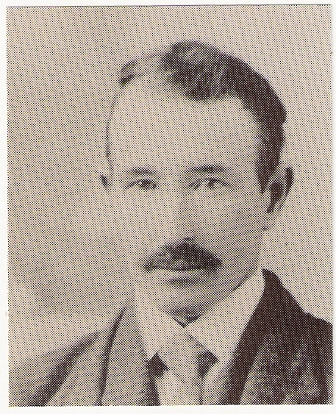
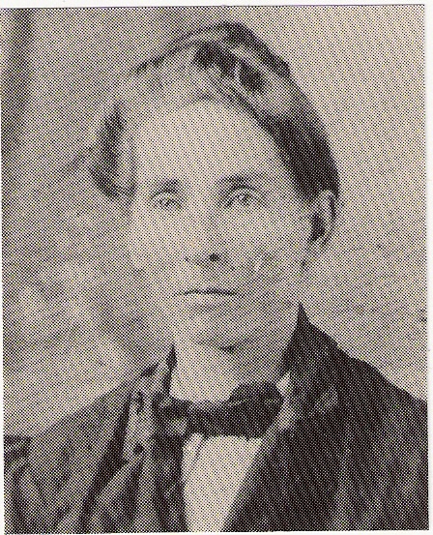.]

George Lee Bunnell Mary Jane (Huffman) Bunnell

GEORGE LEE BUNNELL CB331145, son of George Washington Bunnell CB320747, was born 18 March 1874 in North Carolina. He married MARY JANE HUFFMAN, who was born 30 September 1876. George died in August 1948, and Mary Jane died 10 September 1956. They were buried in the cemetery of the Cumberland Union Baptist Church, Cumberland CO, NC. They were the parents of five children Alice Lee, who died at the age of three years; Berline, m. Hoseh Strickland; Annie, m. William Calfin Faircloth; John, m. Mable Caviness; and Ella, m. Shelton Britt Edge.

* * * * * * *
Paul J. Bunnell, author of THUNDER OVER NEW ENGLAND, BENJAMIN BONNELL, THE LOYALIST, writes that he has opened up an entirely new area of research on his family and Benjamin because shipping comes into the picture quite a bit. It appears that the Bonnells lost their shirts in shipping when their few ships were lost at sea or burnt. He listed three ships belonging to the Bonnells:

E. W. BONNELL, a 198 ton schooner, built for Bonnel & Son by Robert Jenkins. This ship went ashore on one of the Caicos Islands in February 1882.

C. E. WHITE, of 227 tons. The dimensions were 111.4 x 27;.9 x 10.5, built in 1886 at Saint John, New Brunswick, by F. L. Bonnell. F. S. Bonnell was the managing owner and A. L. Bonnell was the Master. This ship loaded a cargo at Digby, Nova Scotia, and headed for Cienfuegos, Cuba, on 1 August 1889 and was never heard from again.

M. L. Bonnel, of 297 tons. The dimensions were 127.4 x 31 x 10.9, built in 1889 at Saint John, New Brunswick, for the Bonnells. Due to hard times the ownership was transferred to F. Ritchie and it was destroyed by fire on 5 January 1897. The ship was named after one of the Bonnell wives, Martha L. Bonnell. Paul has a photograph of a painting of a ship.

We will look to hear more from Paul on this subject as his research progresses.

* * * * * * *

QUERIES

The name and address of the inquirer are included with each query. However, if you are able to provide the inquirer with the information requested, I would appreciate your sending me a copy of your reply.

1. Clarkson, Monroe co., NY, ALLEN BONNELL CB0113467 family, middle 1800’s. Also, DARIUS BONNELL CB004666 family, Rochester, Monroe co, NY, appeared in the 1840 census. Information exchange sought from descendants and genealogists having information on these families. Jewett Bonnell Butler, 7818 Newco Drive, Hamlin, NY 14464.

2. I would like to correspond with other descendants of Lt. TITUS BUNNELL CB300052 and his wife SIBYL VALE. I have recently submitted papers to the Order of the Crown of Charlemagne in the USA on a line which goes through Sibyl Vale. The papers are fully documented and have been accepted. I will correspond with anyone interested. Bess R. Hubbard, 116 E. Ransom St., Fuquay-Varina, NC 27526.

3. Searching for information regarding BARTON BUNNELL, SR., CB320293, who married (1) ANN BIDDLE and (2) MARY ANN BUCKLES, and BARTON BUNNELL, JR., CB330393, who married MELINDA DICE. Linda Doty, 1643 Foxgrove Court, Upland, CA 92786.

* * * * * * *

That’s all for this time. I hope you all have a happy and prosperous New Year.

