
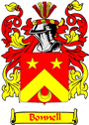
THE BUNNELL/BONNELL
ISSN: 1553-0094

NEWSLETTER

HTTP://www.bunnellfamily.com
Charlie@bunnellfamily.com
Edited & Published by
Charles & Patricia Bunnell

Volume XXV, No. 3 August 2011

A Non-Profit Publication to Assist in Sharing Family Records, Research & Genealogy

Donations are:
Electronic Newsletter Quarterly, printable and downloadable: $10.00/year
Printed, mailed Newsletter, issued Quarterly: $15.00/year
Email account only, yourname@bo/unnellfamily.com: $10.00/year
Email account with printed or electronic subscription No extra charge

Material provided to us is published free in the newsletter.

Contents:
Administrivia 35 Submissions 39
New Members 36 Research Findings 45
E-mail addresses 36 Biographies 49
Direct Lines 36 Queries 53
Life Changes 38 Post Script 54

Important Addresses:
Charlie & Pat Bunnell: 13 Windsor Point, Crossville, TN 38558
William R. Austin: 2720 Hamilton Dr., Endwell, NY 13760
Donald Bunnell: donbun01@yahoo.com (maintains Claude’s database)
Claude’s Website: http://www.williambunnellfamily.org/
DNA & Genealogy: Steven Bonnell, 1523 Good Shepherd Rd, Montoursville, PA 17754
E-Mail: BNL_dna@kbsb.com
DNA Website: http://www.ftdna.com/public/BNL_dna/

Administrivia

Submitting items for the newsletter: To help us keep track of the material, please include your name, address and date on each piece of paper you submit, including photos. For newspaper articles, including obituaries, please include the name of the paper it came from to include the date, city, state and page number. If you have the capability to send in your item electronically, as an attachment to your e-mail, that’s great. But we’ll accept it in any format, so send it in!

Share the Newsletter: We’re not copyrighted, so you can share this newsletter with your local Genealogical Library, Historical Society or family and friends.

New Members

David Bunnell | Evelyn Hanks | Susan Safford
Cheryl Hughes | Michelle Pendleton

E-Mail Addresses

This provides only revisions to the e-mail addresses shown in the November 2011 newsletter.

David Bunnell: | dave@cemlife.com | Evelyn Hanks | 1 Lighthouse@peoplepc.com
Susan Safford | ssafford@zoominternet.net | Cheryl Hughes | JeffandCheryl@hughes.net
Michelle Pendleton | tobyville@mchsi.com | Michelle@bonnellfamily.com

Direct Lines

Elaine Folkins, folkfrye@nb.sympatico.ca, provided her lineage back using her mother’s research notes and some assistance from Steve Bonnell, slbnl@kbsb.com or 1523 Good Shepherd Road, Montoursville, PA 17754. Elaine’s cousin, Janet Bonnell, has her lineage displayed following this one.

William Bunnell ~ Ann Wilmot Crandall Bunnell ~ Catherine Fitzgerald
Benjamin Bunnell ~ Rebecca Mallory James C. Bunnell ~ Emma Steeves
Benjamin Bunnell ~ Hannah Plumb John Calvin Bonnell ~ Olive B. Smith
Gershom Bunnell ~ Margaret Johnson Carolyn Ann Bonnell ~ Briant Henry Folkins
Isaac Bunnell ~ Jerusha Sherwood Elaine Folkins
Daniel Bunnell ~ Emma Sprague

~~~~~~~

Susan Safford, ssafford@zoominternet.net or P. O. Box 143, Lincoln University, PA 19352 provided her lineage back to Solomon and Elizabeth (Holdren) Bunnell and the rest came from the database. She also provided the ancestry of Catherine Cole who is also a Bunnell descendant. So the double lineage forced me to alter the standard Lineage format.

William Bunnell ~ Ann Wilmot
Benjamin Bunnell ~ Rebecca Mallory
Benjamin Bunnell ~ Hannah Plumb
Solomon Bunnell ~ Elizabeth Holdren
Benjamin Bunnell ~ Catherine Barry

James Bunnell ~ Louisa Russell Catherine Bunnell ~ Benjamin Crawford
Hester Bunnell ~ Labon L. Safford Charles Cole ~ Edith Crawford

Landis Safford ~ Catherine Cole
George Safford ~ Grace Shores
Daniel Safford ~ Virginia Johnston
Susan Safford

~~~~~~~

Janet Bonnell, jbonnell@vagent.com, provided her line back to John Calvin Bonnell. Based on her data and that provided by Elaine we now have Janet’s line.
.
William Bunnell ~ Ann Wilmot Crandall Bunnell ~ Catherine Fitzgerald
Benjamin Bunnell ~ Rebecca Mallory James C. Bunnell ~ Emma Steeves
Benjamin Bunnell ~ Hannah Plumb John Calvin Bonnell ~ Olive B. Smith
Gershom Bunnell ~ Margaret Johnson Gerald Ted Bonnell ~ Barbara Carol Gamblin
Isaac Bunnell ~ Jerusha Sherwood Janet Bonnell
Daniel Bunnell ~ Emma Sprague

~~~~~~~

Kathie Sue Bunnell, skills657@yahoo.com, provided about 3 generations of her Bunnell ancestry which was enough for me to pick out the rest from the database. This is one of the unattached branches. Kathie added that “Violet my grandmother was married to Dale Frisk. Violet was pregnant when Dale went to war. He died never knowing his daughter. Then Violet married Alfert Bunnell and he was a father to Hazel. Hazel was deaf.”

Benjamin Bunnell ~ Lucy Simmons Alfert L. Bunnell ~ Violet (Moore) Fisk
Benjamin Bunnell ~ Lieunara Johnson Earl W. Bunnell ~ Verna Wetzbarger
John C. Bunnell ~ Angeline Tate Kathie Sue Bunnell
~~~~~~~

Cheryl Hughes, jeffandcheryl@hughes.net or 2025 Clyde Road, Highland, MI 48357, provided her lineage based on her knowledge back to Truman and Pearl (Dawson) Bunnell and then used Claude’s database to complete it back to William. She noted that the website displayed her parents and older sister and brother, but does not have them connected to her grandfather.

William Bunnell - Ann Wilmot Jonathan Bonnell - Elizabeth Maxwell
Nathaniel Bonnel - Susanna Whitehead Joshua Bonnell – Margaret Cottrill
Isaac Bonnel – Elizabeth Truman Bonnell – Pearl Ann Dawson
Abraham Bonnel - Mary Shinn Almer Bonnell – Letha Brown
Abraham Lt Col Bonnell - Elizabeth Foster James Bonnell – Dorothy Johnson
John Bonnell - Rhulanah Fitz Randolph Cheryl Bonnell – Jeffrey Hughes

~~~~~~~

Michelle Pendleton, tobyville@mchsi.com or 770 Thenius Rd., Sparland, IL 61565, provided her line back to Benjamin Bunnell, father of Benjamin the Loyalist.

Benjamin Bonnel ~ Eleanor Effie May Bonnell ~ Sylvester Starmer
Aaron Bonnell ~ Anne Brotherton Clarence Starmer ~ Ella Butler
Moses Bonnell ~ Hannah Buckingham Alice Mae Starmer ~ Stanley Allensworth
Levi Bonnell ~ Elisabeth Hill Larry Allensworth ~ Arlene Vols
Henry H Bonnell ~ Mary Washington Matkin Michelle Allensworth ~ Todd Pendleton

Life Changes

Obituaries:

Steven Bonnell, slbnl@KBSB.com or 1523 Good Shepherd Road, Montoursville, PA 17754, provided the obituary for his brother Todd. Our condolences go out to Steve and Todd’s family.

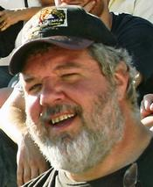
Todd E. Bonnell DC PC, 52, of 2829 Lycoming Creek Road, died Tuesday, June 21, 2011 after being stricken at his chiropractic office on Lycoming Creek Road.

Todd was a member of the Blessed Hope Bible Church. He enjoyed riding his motorcycle, boating, the outdoors and sponsored a men’s fast pitch softball team bearing his name with the amateur softball association.

Todd graduated from the Williamsport High School, the Williamsport Area Community College and the Sherman College of Chiropractic in South Carolina.
Born November 28, 1958 in Williamsport, he was the son of Eugene T. and Eleanor J. Harman Bonnell.

Surviving are brothers, Dale T., Sr. of Allenwood and Steven L. of Montoursville; sister, Darla F. Burkhart of Montoursville, several nieces and nephews.

Todd was predeceased by a sister, E. Janette Bergman.

Funeral services will be at 3 p.m. Saturday, June 25, 2011 at Knight-Confer’s, 1914 Memorial Avenue with the Rev. Dr. Edwin Allabough officiating. There will be visitation from 1 p.m. until the time of the service. A graveside committal service will be at 10 a.m. Monday at Green Lawn Memorial Park.
~~~~~~~

Carol Brotzman, brotzmans@epix.net or R.R.1, Box 1206, Laceyville, PA 18623, sent the following obituary.

Rev. Bernard A. Graham

Reverend Bernard A. Graham, 77 of Montrose (Birchardville), PA passed peacefully into the arms of his Savior, the Lord Jesus Christ on Monday, July 18, 2011 at Community Medical Center with family and friends by his side. Bernard was the son of the late Otis M. and Florence (Tinklepaugh) Graham. He was predeceased by his sister Louise in 1943, a brother Millard in 1968, and a grandson, Brian Graham in 2003. He is survived by his loving wife of over 57 years Glendora L. (Bunnell) Graham, a son David, his significant other, Bonnie LaCount, all of Birchardville, two daughters, Doreen Bowles, her significant other, Mike VanDermark, Newfield, NY, Wendy and husband Rob Cranmer, Little Meadows, PA. He cherished his eight grandchildren, Brendan and wife, Mary Graham, Molly (Graham) and husband Nick Graham, Nathan and wife, Jamie Bowles, Natalie (Bowles) and husband Eddie Vorhis, Jamie Sechrist, Alexander, Whitney and Gabrielle Cranmer. He greatly loved his nine great-grandchildren, David and Isaiah Graham, Brandon and Brian Graham, Clara Graham, Rowan Bowles, McKenzie Brown, Lily and Isabella Vorhis. Bernard is survived by one sister and husband, Arlene and Selden Birchard, Birchardville, PA, one brother and wife, Reginald and Ednita Graham, Christmas, FL, several nieces, nephews and cousins. Bernard loved life and knew how to look for the bright side and humor in everyday events. Next to his faith in God, his family was the most important part of his life. As an avid hunter and gardener, he enjoyed the outdoors and loved all things about God's creation. He loved photography and assembled several albums during his hunting trips and family excursions. He was a past member of the American Hunting Club and the National Rifle Association. Bernard was an ordained minister. He pastored at the Elk Lake Community Church for 18 years and the East Bridgewater Church for 11 years. After retiring as a pastor, he continued to supply churches in need of a speaker in the areas of Northeast PA and Southern Tier NY. He was most recently a member and deacon at Calvary's Love, Johnson City, NY Bernard retired from IBM after 35 years and was a member of the quarter century club. His employment with IBM covered 3 fields; Data processing, Industrial Engineering and Management/Employment Training. After his retirement from IBM, he founded a professional consulting business, Keystone Training, and operated a construction business, Keystone Construction. He was an adjunct faculty member for 18 years in professional training programs, on and off campus, at the State University in Binghamton, NY and also provided consulting for the University in Southern Tier Industries. He was a member of the American Society of Training and Development (ASTD), past VP planning and president of the Southern Tier Chapter of ASDT. He participated in three international conferences of ASTD. He teamed with colleagues in sponsoring a weekend of professional training in the Pocono's for professionals from the Northeast. The family will receive friends from 2-4 pm and 7-9 pm, Wednesday, July 20th at Bartron-Myer Funeral Home, 382 Church Street, Montrose, PA 18801. Family and friends are invited to a graveside service at Birchardville Cemetery, SR 267, Birchardville, PA at 10 am, July 21st, followed by a memorial service at 1 pm with Pastor Jerry Terry officiating at Calvary's Love Assembly of God, Johnson City, NY. Expressions of sympathy in memory of Bernard may be donated to the Elk Lake Community Church, Dimock, PA 18816, the East Bridgewater Community Church, Montrose, PA 18801, or Calvary's Love Assembly of God, 1315 Reynolds Road, Johnson City, NY.

[Ed. Note: Glendora L. (Bunnell) Graham is 033861 in Claude’s database. Her lineage is: William¹, Benjamin², Nathaniel³, Ebenezer⁴, Israel⁵, Israel⁶, Edward⁷, James⁸, Charles⁹, Ralph¹⁰, Glendora¹¹.]

Submissions

In the last issue (page 27), I wrote about Dan Keeley, dankeeley@bajabb.com, of British Columbia, Canada. He had sent his family history tying back to a Hannah Jane Bunnell. I disagreed with his lineage and provided my rationale in the newsletter and to him. After reading my discussion, he agreed with my findings and provided some photos. Hannah Jane Bunnell is 330281 in Claude’s data base as Jane Bunnell, and was the wife of Levi Smith.

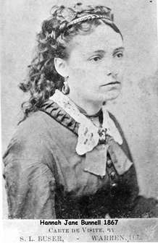
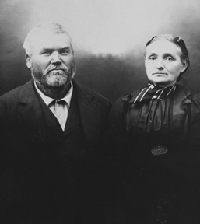
Levi Smith and Hannah Jane (Bunnell) Smith
Taken about 1910

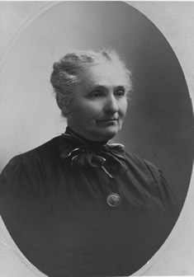
Hannah Jane (Bunnell) Smith
Taken about 1918

~~~~~~~~

Jim Tidball, jim33@telus.net of Vernon, British Columbia, Canada, also a contributor to the article that started on page 27 of the previous issue, sent some additional photos of Hannah Jane (Bunnell) Smith and family members.
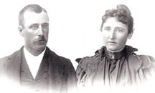
Probably Mark & “Maggie” (Bunnell) Lewis; brother-in-law and sister of Hannah Jane (Bunnell) Smith
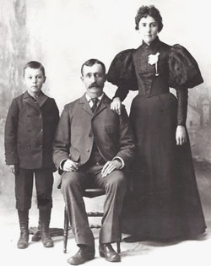
Hannah Jane Bunnell and one of her younger brothers; the little boy is unidentified.
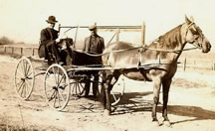
Chester & Ed Bunnell, cousins of Hannah Jane (Bunnell) Smith; photo taken 1911, San Bernardino, CA

~~~~~~~

Susan Reedy, 3reedy@gmail.com, had been corresponding with me regarding a Lucille Bunnell who married into the Paugh family, all part of her husband’s ancestry. Though not related to his ancestry, she provided some information about and, a photo of, the Samuel Bonnel home in Middletown, Ohio:
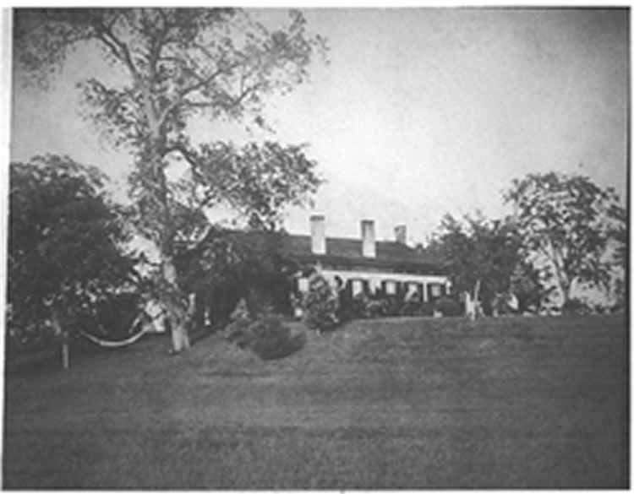
Original Samuel Bonnel’s home
“Thought you might enjoy seeing Samuel Bonnell's home built in 1839. It was bought and added on to by Colin Gardner in the late 1800's and was known as The Gardner Mansion. In 1981 I attended art classes in the mansion which at the time was owned by Miami University Middletown Branch. The home is currently owned by John & Jennifer Ridge who is my daughter's 4H advisor. The address is 2 Gardner Place, Middletown, OH 45042. It is right off Rt 4.”

She also suggested googling it and I found the following at the Urban Ohio website
(http://www.urbanohio.com/forum2/index.php?topic=8047.0):

“[The Gardner place] was actually built as a farm house in 1839 by Sammuel Bonnell on a 127 acre tract he had purchased. Colin [Gardner], who was originally from Cincinnati, moved into the house in 1892. He extensively remodeled and expanded the home to its impressive Greek Revival state. When the current owners began a renovation project, they uncovered the signature of Dayton architect J.P. Joyner signed 1891. Gardner Mansion has 23 rooms and nine fireplaces. According to the Butler County Auditor's web site, the house is nearly 5,500 square feet. I'm not sure that is completely accurate though. After Colin's death, they donated the home to Miami University to use as a cultural center. This was prior to the establishment of a permanent campus. Miami sold the home to private owners. Today it is owned by John and Jennifer Ridge, a dermatologist and founder one of the first internet service providers in the Miami Valley, Infinet.”
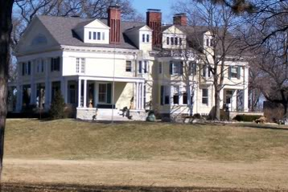
Current photo of Remodeled & expanded Home
~~~~~~~

In the last issue we had a lot of data provided by Steve Glazer, w2sg@aol.com, of the Cranford, NJ Historical Society. On page 26 we noted that Steve and I were trying to determine if John F. Bunnell of Blairstown (CB330694) had actually served in the Civil War. Our source for the contention that he had served was the 2006 book Our Brothers Gone Before. Corresponding with the author, Steve found that the author “included the names of men who had flags placed at their graves on Memorial Day.” Steve and I have agreed that John Fletcher Bunnell had not served in the Civil War.

Then on page 33, I stated that we would have more material on this John F. Bunnell of Blairstown, NJ. As I was researching I found that I was becoming confused over various dates that events occurred and realized that there were two John F. Bunnells in Blairstown, for much of the same time frame.

John F. Bunnell (CB320234) was born 1817 in Sussex Co., NJ and moved to Knowlton/Blairstown (in 1845 Blairstown was formed out of Knowltown; so he may have been in an area that became Blairstown) by 1840. He died in 1900 and was buried in the J.I. Blair Cemetery in Blairstown.

His brother Isaac also moved to Knowlton by 1840. Isaac was the father of our second John F. Bunnell. He was born in 1843, died in 1917 and was buried in Cedar Ridge Cemetery in Blairstown. His tombstone can be viewed at http://newjerseycivilwargravestones.org/view.php?id=1288. (Steve said to: “Ignore the info shown under the picture about "Isaac Bunnell." He was NOT a Civil War vet; they have the wrong ‘Isaac Bunnell.’") This same tombstone lists John’s parents, Isaac and Margaret Bunnell.

Here is what I was able to find out about our “Johns” with the help of Steve Glazer:

Census Data, especially that showing occupations, will help sort out information from other sources cited below:

1840, Knowlton, Warren County, NJ
- Isaac Bunnel whose family consisted of 2 free white persons under 20 and 2 free white persons – 20 to 49.
- John Bunnel whose family consisted of the same mix of 2 under and 2 over 20 years old.

1850, Blairstown, Warren county, NJ
- John Bonnel, carriage maker; Mercy [his wife]; children: Peter, Nehemiah.
- Isaac [indexed as Berwell in Ancestry.com], farmer; Margaret [his wife]; children: Charles L., John F.

1860, Blairstown, Warren county, NJ
- John Bonnell, merchant; Marcy [his wife]; children: Peter, Phebe, Sarah, Jennie, Anna M.
- Isaac Bonnell, farmer; Margaret [his wife]; children: Charles, John F., Leslie.

1870, Blairstown, Warren county, NJ
- John Bonnell, Dry Good Merchant; Mercy [his wife]; children: Peter, Phebe, Sarah, Nancy Jane, Anna.
- Isaac Bonnell, Farmer; children: Lesley, John F.(works on a farm) w/wife Anna.

1880, Blairstown, Warren county,NJ
- John Bonnell, retired merchant; wife Marcia; children: Jennie, Annie.
- Isaac Bonnell, retired farmer, wife Marcey; children: John F, farmer, w/wife Annie; grandson: Charles.

1895 New Jersey State Census, Blairstown, Warren county
- John Bunnell, wife Marcia L. and daughter Jennie A.
- John F. Bunnell, wife Anna J.; stepmother, Marcia.

1900 Blairstown, Warren county, NJ
- John Bunnell, retired; Carrie Lance is servant.
- John F. Bunnell, farmer, wife Annie J.; stepmother, Marcia.

1910 Blairstown, Warren county, NJ
- John F. Bunnell, dealer farm implements, wife Annie J.; son, daughter-in-law, granddaughter, grandson.

From Blairstown and Its Neighbors, By Kenneth Bertholf, Jr., Don Dorflinger:

Page 35:
“… 165 Free and Accepted masons received its charter and held its inaugural meeting with John Fletcher Bunnell installed as worshipful master.”

Page 39:
“The Valley View House on High Street was built by John Bunnell in1868 and was operated by Mary L. Albertson in 1915. It could accommodate 25 guests …” [I expect that this is John F Bunnell, b. 1817.]

Page 43

“John Fletcher Bunnell lived in this opulent home on Park Street, just below the sprawling campus of Blair Academy. Bunnell had a successful carriage manufacturing business and was a ruling elder of the Presbyterian church. He also served as the first worshipful master of Blairstown Lodge No. 165, Free and Accepted masons when it received its charter in 1893.”
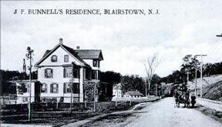

Page 65:
“In 1848, the Blairstown town fathers and officials of the Presbyterian church agreed that it was time to establish a school. On April 6, a meeting was held to determine an appropriate site, with John I. Blair; John A. Reiley, minister of the First Presbyterian Church; and John Bunnell, a local carriage maker, in attendance. …” [This is John F. Bunnell, b. 1817 – the other John F. was only 5 years old at this time]
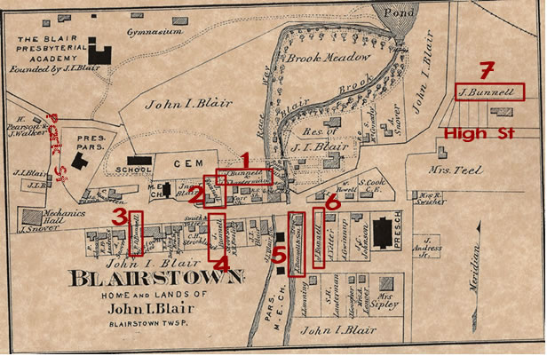

On the previous page and below are maps of Blairstown in 1874. On the first map I have identified with boxes all Bunnell properties; street names are based on current maps. Below is the same map, sans boxes.
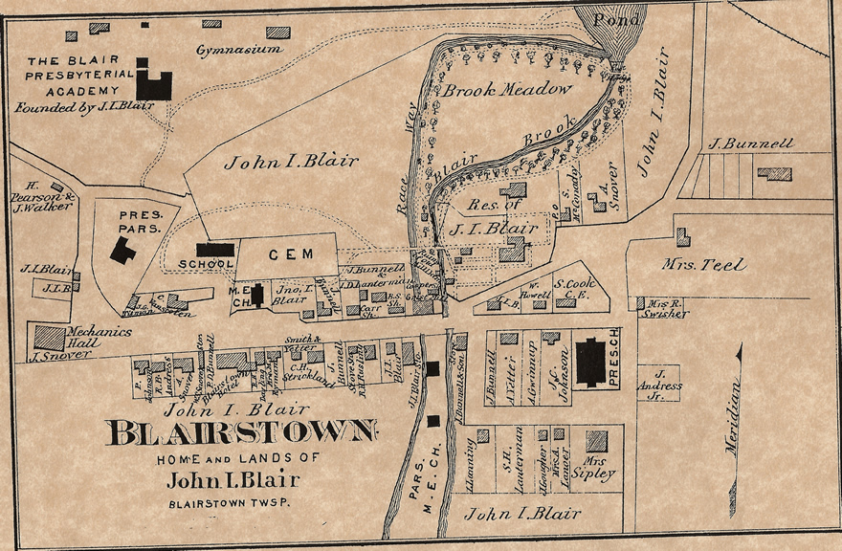
The maps show several Bunnell properties, most of them are J. Bunnell, assumedly John F. Bunnell. No 1 property on the map is a joint ownership between J. Bunnell and I. D. Lanterman and included on the lot is a carriage shop which fits his occupation in the 1850 census and the comment regarding his trade in the 1848 meeting cited above in Blairstown and Its Neighbors. No. 2 property belongs to J. Bunnell, is adjacent to the carriage shop, but the use of the building thereon is not stated. No. 3 property is owned by P.D. Bunnell who must be John F.’s son, Peter. The Blairstown Hotel is on that. No. 4 appears to be vacant property also owned by J. Bunnell. No. 5 is the site of a store and is owned by “J. Bunnell & son.” No. 6 is apparently another vacant lot owned by J. Bunnell. Finally, No. 7 may only be a lot owned by J. Bunnell or it could include the building just below his name and that could be the “Valley View Hotel built by John Bunnell.” The “opulent home on Park Street” that belonged to John Fletcher Bunnell appears not to be shown on the map, based on current street names.

While it is easy to confuse the two John F. Bunnells, here is my interpretation of the information we have:

John F. Bunnell, CB320234, b. 1817, was in Blairstown by 1840; was a carriage maker and merchant. His middle name was also Fletcher, based on the citation on pages 35 and 43 of Blairstown and Its Neighbors; He owned several properties in town and resided on Park Street. He built the Valley View House in 1868. The verbiage attached to the picture of the house on Park Street provided the necessary information to tie together all the info on this man.

John F. Bunnell, CB330694, nephew of the above John F. Bunnell, was born 1843. Claude’s database shows him as being born in Sussex Co, NJ, but I believe that he was born in Blairstown. The 1840 census shows his parents as being there so while it’s possible his mother went back to Sussex Co. while awaiting his birth, it is unlikely. Up until the 1910 census he was a farmer. What I have not found is a reference for his middle name to be Fletcher. Claude’s database shows it as such, perhaps based on his references from #13 Masonic Lodge at Belvidere. I have doubts that those citations are referring to this John Bunnell; rather I believe they are talking about his uncle. I can find no other reference for his middle name, though census records confirm his middle initial.

Research Findings

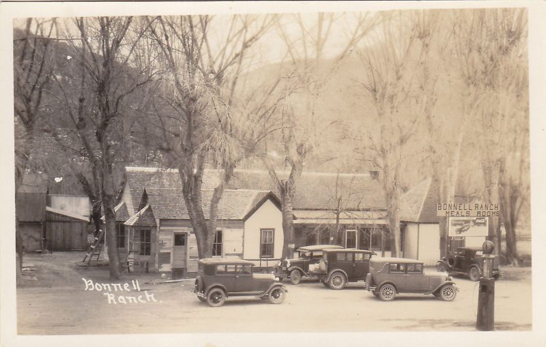
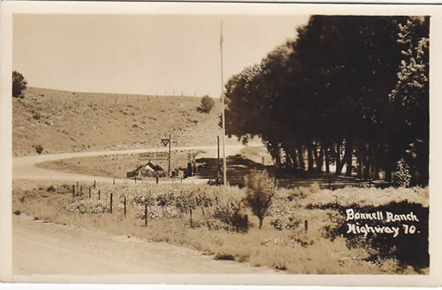
In past issues we carried the history of the Bonnell Ranch in Glencoe, New Mexico. It started in Vol. 20, No. 4, page 67 with a query about a postcard I had found on e-bay. Some additional photos and some of the background about the ranch were provided in Vol. 21, No. 1, starting on page 5. Then, in Vol. 21, No. 2 (May 2007), starting on page 37, we carried the full history of the ranch and its founder, Bert Jay Bonnell. Now I have discovered a couple more postcards of the ranch on e-bay and offer them here.

~~~~~~~

From Hardin County, Kentucky Marriage Records, 1813-1850, by Frances Terry Ingmire, Mountain Press, 1983.

Groom Bride
Page 22:
Coleman, Chenault; Father: Thomas Bunnell, Martha, Father: William 7/3/1830

Page 57
Howey, James S. Bunnel, Sarah, Father: William 3/2/1834

[Ed. Note: I was not able to find either of the two women in Claude’s database.

~~~~~~~
From Metcalfe County, Kentucky History and Biographies, Mountain Press, Signal Mountain, Tennessee, containing information taken from: History of Kentucky, Lewis Collins, 1882 and Kentucky: A History of the State, W.H. Perin, J. H. Battle and G.C. Kniffin, 1885. Page 20:

“MRS. MARTHA L. IRVIN was born in Metcalfe (then Barren) County, July 12, 1844. Her father, John Forbes, was born about 1814, also in Metcalfe County (then Barren), Ky., where he died about 1855. He was a son of John Forbes, who was a native of Virginia and of English descent. John Forbes was twice married; his first wife, whom he married in 1835, was Elizabeth, daughter of Peter and Susan (Irvin) Bunnel. To this union were born Louisa (Smith), Sarah (Garvin), Martha L. (our subject), Margaret (Bishop) and Charles G. He was next married to Nancy Jewell. Our subject was married, November 15, 1863, to Joel, son of William and Sarah (Forbes) Irvin. He was born March 2, 1822. To them were born John W., Dora B. and Charles. Mrs. Irvin has at present 128 acres of productive land, besides which she has one of the best houses in her section. She has been for twenty-two years a member of the Christian Church.”

[Ed. Note: Peter and Susan (Irvin or Erwin) Bunnell are part of the Kentucky mystery. Elizabeth is 000846 in the data base.]
~~~~~~~
From Hardin and Harding of Virginia and Kentucky, compiled and published by Dorothy Ford Wulfeck, 1963,

Pages 3-4; Queries from the Virginia Gazette:
5935. March 17, 1961. BUNNELL-HARDIN-WALTON. Samuel Washington Bunnell, son of Jeremiah and Rebecca (Hardin) Bunnell, m. Barren Co., KY., 1849, Sarah Walton. In 1850, Barren Co., he m. Frances Walton, sis. Of Sarah. Sarah and Frances were daus. of John and Elizabeth Walton. Samuel W. and Frances (Walton) Bunnell had the following children: Sarah E., Rebecca, Me_____ (female), all resided in Hart Co., Ky. Can anyone tell me who these 3 daus. married? (John Paul Grady, Box 398, Roswell, New Mex.)

Page 76, Mercer County, Kentucky
Rebecca Hardin m. 27 Nov., 1804, Jeremiah Bunnel.

~~~~~~~

Steve Bonnell, slbnl@kbsb.com or 1523 Good Shepherd Road, Montoursville, PA 17754, included me in some e-mail traffic with a Janet Bonnell, jbonnell@vagent.com. She wrote that:

“My grandfather’s name was John Bonnell, I believe he died 1968. The first half of my grandfather’s children lives in the United States. Some of his children’s name were June (lived in North Carolina), Harry (lived in NY), Stephen (lived in NY), Calvin, Carson, and I’m not sure if there are more children or not. The other half of his family live here in Canada. He married Olive Beth Smith and had 7 children: Douglas (put up for adoption), Gerald (Ted), Patricia, Harold, Richard (died at 16), Carolyn and Owen (died at 16).”

Going to Claude’s database I was able to find John Calvin Bunnell and his two wives, but the children of only one: Olive Smith. I looked in my own database and found John Calvin and one of the sources I listed was 2009 e-mail traffic between Steve Bonnell and Elaine Folkins, folkfrye@nb.sympatico.ca, which resulted in Steve identifying Elaine’s ancestry back to William the immigrant. Elaine’s grandfather was John Calvin Bo/Bunnell. That research resulted in a correction to the database renaming John Sherwood Bunnell to John Calvin Bunnell. With the addition of Janet’s father’s name, we were able to connect her to the same line. In fact Janet’s father and Elaine’s mother were siblings whose mother was Olive B. (Smith) Bunnell. Their lineage is shown in the Direct Lines section of the newsletter.

From Ancestry.com, Border Crossings from Canada to U.S.. 1895-1956

Name: | John Calvin Bonnell
Arrival Date: | Oct 1926
Port of Arrival: | Niagara Falls, New York, United States
Accompanied by: | Cousin Leonard Sherwood
Arrival Contact: | Cousin Foster Sherwood
Departure Contact: | Wife Mary
Age: | 44
Birth Date: | 1 Jan 1882
Birth Place: | Penobsguio, New Brunswick
Gender: | Male
Race/Nationality: | English

Name: | Charles William Bonnell
Arrival Date: | 18 May 1927
Port of Arrival: | Niagara Falls, New York, United States
Accompanied by: | Mother Mary
Arrival Contact: | Father John C Bonnell
Departure Contact: | Grandfather Grandpa Ebenezer G Warren
Age: | 9
Birth Date: | 26 Jan 1918
Birth Place: | Birch Siding, Nova Scotia
Gender: | Male
Race/Nationality: | Scottish

Name: | Hannah J Bonnell
Arrival Date: | 18 May 1927
Port of Arrival: | Niagara Falls, New York, United States
Accompanied by: | Mother Mary
Arrival Contact: | Father John C Bonnell
Departure Contact: | Grandfather Grandpa Ebenezer G. Warren
Age: | 11
Birth Date: | 7 Jun 1915
Birth Place: | Birch Siding, New Brunswick
Gender: | Female
Race/Nationality: | Scottish

From Ancestry.com, Canada, Soldiers of the First World War, 1914-1918
Name: | John Bonnell
Birth Date: | 1 Jan 1882
Birth Location: | Pendlesques New Brunswick
Relative: | Crandell Bonnell
Regiment Number: | 34130
Date of form: | Sept 25, 1914

[Ed. note: Interesting that John’s birth date is listed as 1 Jan 1882 in the two documents above. In the 1911 census, when he is single and living with his mother, his birth date is listed as January 1885. His cemetery record records his birth date as 1884. Crandell Bonnell above is John’s grandfather.]

Elaine’s mother, Carolyn Ann (Bonnell) Folkins had done considerable research regarding her half siblings and gave that to Elaine, who forwarded copies to me and posted the family tree on Ancestry.com. Using that material, information Janet provided, plus other sources on Ancestry.com and Claude’s data base, the children of John Calvin Bonnell and both wives are provided below:

John Calvin Bonnell- born 1 Jan 1882 in Penobsquis, CN. died 7 Jan 1968 in Penobsquis, CN.

Married (1) Mary Elizabeth Agnes Warren, b. 25 Jan 1890. Issue:

- Lenard Carson Bonnell b. 23 Sep 1922; d. 1986
- Percy Calvin Bonnell b. 16 Jun 1920; d. 1990
- Harry Roy Bonnell b. 25 Jan 1914; d. 13 Jul 1990
- Fred James Bonnell b. 31 Oct 1916
- Hannah Jean Bonnell b. 7 Jun 1917
- Charles William Bonnell b. 26 Jan 1918; d. 09 Jun 1944.
- David George Bonnell (adopted as a Hammond?) b. 25 Apr 1924

Married (2), 23 Aug 1942, Olive B. Smith, born 11 Feb 1923; died 13 Jul 1964. Issue:

- Charles Leslie Bonnell (adopted name = Doug Arnold) b. 21 Jun 1939
- Gerald Ted/Roy Bonnell b. 3 Jul 1942; d. 1980
- Patricia May Bonnell b. 15 Jun 1944
- Richard Clarke Bonnell . 23 Feb 1947; d. 13 Jan 1963
- Harold Grant Bonnell b. 22 Aug 1949; d. unk
- Carolyn Ann Bonnel b. 1Jul 1951
- Vaughn Owen Bonnell b. 22 Aug 1956; d. 11 Nov 1972

A brief sketch of John Calvin Bunnell’s life and family was provided by Janet and Elaine:

We know that he had two birth certificates. This was to do with being able to sign up for the military. He was married twice, having two large families. Most of his first family still resides in Buffalo, NY. Some of his children’s name were June (lived in North Carolina), Harry (lived in NY), Stephen (lived in NY), Calvin and, Carson. His second family, still resides in Sussex and area, New Brunswick, Canada. Not sure how this connection evolved. Apparently, when John and Olive got together they had a son which they eventually put up for adoption, whom the family has now found named Doug Arnold, original name being Owen Bonnell. They then proceeded to have another son (Gerald "Ted" Bonnell) and decided that they should marry. They then proceeded to have more children: Harold, Patricia, Richard, Carolyn, and Vaughn Owen.
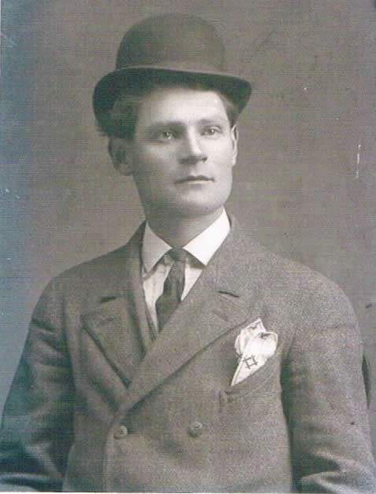
John Calvin Bonnell
(courtesy of Elaine Folkins)

Carolyn (Bonnell) Folkins, daughter of John and Olive Bonnell, said that John’s first wife's name was Mary E. Bunnell and she is buried somewhere in the US. Charles William Bunnell, from John’s first marriage, was in the military. He is buried in Brettevill-Sur-Laize Canadian War Cemetery. He was a gunner for the Royal Canadian Artillery died age 26 on June 9, 1944. He was married to a woman named Elizabeth Bunnell of Barker NY, USA. Other names Carolyn remembers from her father's first family are his children: Carson (who was the man who raised Carolyn), Calvin, Harry, Fred, Jean, and Charles (who they called Bill) and there was another boy David who was put up for adoption.

Vaughn & Richard (full brothers from the second marriage) both died at age 16. They were both killed in drinking and driving accidents, being the victims in each isolated case. Richard was walking home from hockey practice and was struck down. Vaughn Owen was driving his half-brother Carson home and was in a head on collision with a drunk driver and died instantly. However Carson survived this accident and blamed himself until the day he died. Carson died later in life of bone cancer (he never married or had any children). However, he was the one man Carolyn called Dad, as he raised her from her early teens on.

We are left with a few unanswered questions: The 1930 census for Lackawanna City, Erie Co., NY has a John C Bonnell there but his wife is either Alice or Alisa. Children listed and their ages are:
- Harry Bonnell 16
- Hannah Bonnell 14
- Fred Bonnell 13
- William Bonnell 11
- Gastvas Bonnell 9
- Carson Bonnell 7
- David Bonnell 6
- Brownie Bonnell 3

Everyone except Brownie is listed as being born in Canada; Brownie is listed as born in NY. All of the others are also cited as immigrating to the US in 1925. There are border crossing documents showing John as coming over in 1925 while son Charles and daughter Hannah came over in 1926. I realize that their 1927 crossing documents might be simply not available.

But the unanswered questions are:
1. Who is this Alice or Alisa? Did Mary have a middle name she went by?
2. Some of the children's names don't match what we developed; did some of the kids use nicknames for that census?
Biographies

From History of Dansville, N.Y., 1789-1902; Edited by A. O. Bunnell, compiled by F. L. Quick; Instructor Publishing Company, Dansville, N.Y. I’m sure this is a reprint of the original book, but there is no identification of by whom, where or when the reprint was done.

Page 9:
“A.O. Bunnell
No newspaper man in the state of New York, and probably none in the United States, is more widely known and more generally loved than A. O. Bunnell, the editor of the Dansville, N.Y., Advertiser. For over half a century (1852-1902) the smell of printer’s ink has been upon his garments. Born in Lima, Livingston county, N. Y., march 10, 1836, he moved to Dansville at the age of fourteen, and at sixteen became a printer’s apprentice. In 1860, he founded the Dansville Advertiser, and has ever since remained its editor and publisher. The paper typifies the man. It is a beautifully printed paper – clean and wholesome in its contents, elevated in its moral tone, and powerful in its widely exerted influence. But this is not surprising, for Mr. Bunnell inherited the best of American tendencies. He was the third of five children of Dennis Bunnell, four of whom are living – Miss D. B. Bunnell, a resident of Dansville; Mrs. Mary Bunnell Willard of Brooklyn, N. Y., and Major Mark J. Bunnell of Washington, D. C., constituting the other surviving members of the family.
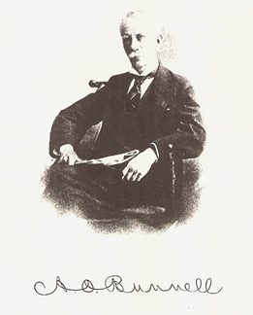
Dennis Bunnell was the youngest of the seven sons of Jehiel Bunnell of Cheshire, Conn., a revolutionary soldier and a member of an old and leading family. Jehiel Bunnell’s wife was one of the Hotchkiss family, prominent in the early history of Connecticut. A. O. Bunnell’s mother was Mary Baker, daughter of James Baker, a sturdy pioneer woodsman and hunter, whose wife, Mary Parker, was the elder sister of three celebrated pioneer Methodist circuit preachers of western New York – the Rev. Messrs. Robert, Samuel and John Parker. All these ancestors are dead, Dennis Bunnell entering into his rest in 1885 and Mary Baker Bunnell in 1881.
Mr. Bunnell has never sought public preferment. The love of his profession has kept him loyal to it. In the congenial atmosphere of the printing office, as boy and man, he has taken his greatest delight and realized his highest ambitions. Modest and retiring by nature, he has still, by the force of his character, become a leader in his profession. For thirty-four years he has been secretary and treasurer of the New York Press Association, and much of the success of this influential association-probably the most progressive and vigorous of its kind in the country-is concededly due to this ability, energy and industry. In grateful recognition of this fact, on the twenty-fifth anniversary of his connection with the organization, his associates presented to him a superb, solid silver tea set, costing over five hundred dollars. He became a member of the New York Press association, on its reorganization, after the war, in 1865, and three years later was chosen its secretary, continuing in that office ever since.
On the organization of the Republican Editorial association of the state of New York, January 10, 1894, in which Mr. Bunnell was deeply interested, his associates unanimously chose him as secretary and treasurer of that body. In July, 1894, the National Editorial association, at its annual meeting at Asbury park, elected Mr. Bunnell as president of that great body of editors, in which office he served until January 24, 1896. On that date, the members of the association, after the convention proceedings held in St. Augustine, Fla., presented to their retiring president, a handsome cane and a set of souvenir gold and sliver orange knives and spoons. In accepting this handsome gift, Mr. Bunnell captivated his hearers by his most feeling and felicitous words. He said: … [Lengthy speech omitted –available if desired]
No member of the national association is more beloved than Mr. Bunnell and no president of that body ever presided with more dignity and satisfaction than he. As special representative of the Pan American Exposition company, Past President Bunnell’s effort at New Orleans in 1900 secured the convention of the National association for Buffalo in 1901. When the National Republican Editorial association was organized at Philadelphia, June 18, 1900, largely through the efforts of Mr. Bunnell and some of this associates in the New York Republican association, Mr. Bunnell was chosen secretary and treasurer, a place which he still holds. He has also been president of the Livingston County Press association; was one of the organizers, in 1877, of the Livingston County Historical society, of which he has been president and is now one of the councilmen; was active in the organization of The Coterie, the oldest literary society of Dansville in existence, and, in fact, has been foremost in every movement of the development of the literary tastes of the community. He has been trustee of the Dansville seminary, is deeply interested in its High school; is one of the directors of the Dansville & Mt. Morris railroad, and for a long period has been a trustee of the Greenmount cemetery. His connection with the Independent Order of the Odd Fellows has been most honorable and distinguished, and, in 1884, he was selected to the exalted position of Grand Master of the New York state organization, filling this place, as he has filled every other which has come to him, with singular fidelity.
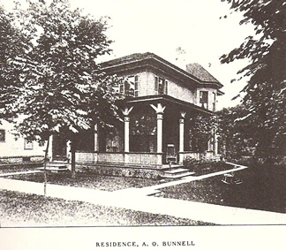
On April 9, 1863, Mr. Bunnell was married to Anna M. Carpenter, in Lyons, N. Y. Of their children, one daughter and two sons, only the daughter, Mrs. Albert Hartman of Dansville, survives. The death of Mark H. Bunnell, the only surviving son, at the age of nineteen years, was a loss which every one who knew this brilliant young man most deeply mourned. As a lad, Mark H. Bunnell was precociously bright, loving books and study and revealing many of the admirable traits and literary inclinations of his father. He was a careful reader of all the best books of his time and a student of politics and history. He love music and art, his tastes were refined and he sought the best and most helpful associations. It is not surprising that his parents looked forward with eager hope to a brilliant future for their son, and when on the threshold of his young manhood, he was stricken by illness, which, after a period of eight months, terminated fatally on the 10th of November, 1893, the profoundest sympathies of the entire community were tendered to his bereaved parents. This was a sad and fearful blow, inflicted the mysterious hand of Providence, but it was borne with splendid patience and Christian fortitude by the bereaved ones.
The live of Mr. Bunnell has not been crowded with events of extra-ordinary interest. His story has been the tale of an even-minded, kind-hearted, generous, helpful man, who has found his greatest satisfaction in holding up the hands of the weak and strengthening the purposes of the strong. Beautiful in his home life, successful in his professional career, honored as few men have been by his newspaper associates, and profoundly respected in his own community, he lives to realize the fact that man’s success in life is best measured by the sweet and lasting contentment which a record of good deeds must always bring. – John A. Sleicher, Editor Leslie’s Weekly, New York City. “

[Ed. Note: One can’t help but wonder how he had time to publish his paper with all the organizations he oversaw. A.O. Bunnell, Asahel Othello Bunnell according to the database, is 320092 in the database. While the article states that two sons were born, the name of only one is provided. I was not able to find the name of the other son. A.O. Bunnell’s lineage is: William¹, Benjamin², Nathaniel³, Abner⁴, Jehiel⁵, Dennis⁶, A. O.⁷.]
Part I, Page 258:
“Dennis Bunnell, father of A. O., and Major Mark J. Bunnell, died July 2, 1885, in his seventy-ninth year. He was respected by his acquaintances for his unassuming sincerity and earnest convictions and beloved by his family for his affectionate and loyal domestic nature. He was an ardent whig [sic] and then republican and through the papers kept in close touch with political events. It was largely owing to his persistent efforts that the excrescences on the public square were removed, and it became a source of pride instead of shame to the village.”

Part II, Local Industries, Page 192:
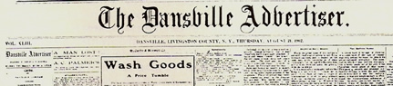

The present owner, editor and publisher of the Dansville Advertiser, A. O. Bunnell, started the paper in a very modest way August 2, 1860, as a small advertising sheet, not anticipating that it would develop into the much larger weekly of wide and weighty influence which it not long afterwards became and has continued to be. Because he intended it as an advertising medium chiefly he named it the Advertiser, and when its advertising became secondary to its news, editorials and miscellany, he conservatively refrained from changing the original name. He has told a little story about his sensitive timidity on issuing the first number. So nervous was he that when he left the office he hurried through a back street, and reached home in a roundabout way with a sigh of relief from having escaped a gauntlet of the possible comments on Main street. Gradually he grew out of these flutterings [sic], and thought better of himself and his printed child.
Nearly two-thirds of the time of the Advertiser’s existence Mr. Bunnell has been alone in its ownership and management. About fifteen and a half years in all he had partners. Prof. Joseph Jones, of blessed memory, was associated with him as partner from July 1, 1866 to July 1, 1868, having stepped from the principalship [sic] of the Dansville Seminary into the newspaper harness. After sixteen years more of exacting labor with undivided responsibility, Mr. Bunnell received another partner, W. S. Oberdorf, whom he had educated to be a printer, who had afterward graduated from the Geneseo State Normal School with high honors, and then for two years done editorial work on the Geneseo Republican. The new partner confined himself mostly to the business end of the office, and proved an efficient and enterprising helper. His health failing, so that he had to withdraw entirely form office duties or other labor for many months, the partnership was finally dissolved. It began March 1, 1884, and ended October 1, 1897.
In 1871 Mr. Bunnell bought the present Bunnell block in the center of the business section of Main street, a three-story brick building with two stores on the ground floor. The entire second floor is used for the editorial, composing, press and engine rooms; the third floor for packing and storage. The Advertiser office has long been regarded by visiting printers and journalists as one of the best equipped and most attractive of country offices. The room occupied by editor, stenographer and book-keeper, has an inviting and almost ornate interior, including walls with suggestive pictures, three oak folding desks, a large safe, cabinet file, copying press, book cases and case for the bound volumes of the Advertiser. All rooms are steam heated.
Mr. Bunnell, although a Republican from the formation of the party, did not intend to publish a political newspaper. But the Advertiser was started on the very eve of the great Civil war, when the stirrings of the coming strife were in every man’s heart, when the inherited blood of revolutionary ancestors tingled in every patriot’s fingers, and the editor could not resist the imperious impulse to ardently advocate the political principles of the administration upon which had fallen the supreme duty of preserving the Union. So it naturally came about that from the first year the Advertiser has been a strong Republican newspaper. The Advertiser has also strenuously supported all local movements which to the editorial mind promised to be of public benefit. Among these have been the agitations which resulted in the raising of companies for the Civil war, and in the town’s first railroad, the first waterworks for extinguishing fires and the second for domestic as well as fire purposes, the beautiful Greenmount cemetery, the Union school, the circulating library, the improvement of parks and streets and the establishment of new manufactories. Of the Jackson Sanatorium on the hillside, which has been of great benefit to the village as well as its thousands of patients, the Advertiser has always been an ardent advocate, and for years the office published its famous health magazine, the Laws of Life, which reached a circulation of 10,000 copies. The literary quality of the Advertiser’s original articles and selected miscellany has always been of a high order of merit, and the general motive of the paper has been educative and enlightening, taking broad and liberal views especially of church and temperance work. The columns of the Advertiser have been notably rich in local history and biography, as acknowledged by county historians years ago and this year by the writer of the History of Dansville.
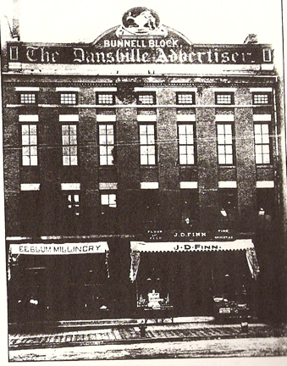
~~~~~~~

Michelle Pendleton, tobyville@mchsi.com or 770 Thenius Rd., Sparland, IL 61565, has been researching her Bonnell/Bunnell ancestry and ran across this interesting biography. It is from General History of Shelby, Missouri; Henry Taylor, Jr. and W. H. Bingham; published by Henry Taylor & Company, Chicago, 1911, pages 629 – 630

Henry H. Bonnel. (Deceased.)
Finding his country in the throes of a terrible civil war soon after dawn of his manhood, Henry H. Bonnel, who was one of the prosperous and progressive farmers of Bethel township in this county, took his place in the army of defense, and during the momentous conflict bore his burden of service, with all its involvement of peril and privation, arduous labor and dark uncertainty. Then when peace was restored, and the armies so lately engaged in deadly warfare melted away into the hosts of industrial production, he turned once more to the cultivation of field and farm, in which he was actively and successfully engaged, devoting to it the same fidelity and energy that distinguished him in the march and on the battlefield of military service until his death in 1910.
Mr. Bonnel was a native of Batavia, Ohio, born on April 10, 1835. He was a son of Levi and Elizabeth Smith (Hill) Bonnel, the former born and reared in Pennsylvania and the latter in Ohio. They had eight children and six of them are living: Henry H., Aaron, Mark, Anna Eliza (Reynolds), Mary Amelia (McDonald) and Frank. The father brought his family to Missouri in 1861 and located in Shelby county, where he engaged in farming and raising stock, pursuing these lines of useful endeavor until his death in 1874. The mother survived him eighteen years, dying in 1892.
Henry H. Bonnel was reared in his native place and educated in its public schools. He was warmly attached to his home and his parents, and after leaving school remained with them, assisting his father on the farm, and accompanying them to this state when they migrated to it. In January, 1862, on the 16th day of the month, he enlisted in a company of Missouri cavalry, and was soon afterward at the front and in the midst of the fray, which from that time on to the close of the war was constant and terrible. He took part in numerous important battles and many engagements of minor consequence, and, although often face to face with death, escaped unharmed while his comrades fell like autumn leaves all around him. Before the end of the struggle he became quartermaster-general of Company I, being promoted to this position in recognition of the value of this service in the sterner phases of the conflict.
At the close of the war Mr. Bonnel returned to this Shelby county home, and here he was profitably engaged during in farming and raising stock, except during the last two years, when he lived retired from all active pursuits. During his residence in this county he has ever taken an earnest interest and an active part in promoting the welfare of the region, doing at all times all he could for the benefit of its people, the development of its resources, and its moral, intellectual and material advancement in every way. He was clerk of the district for more than twenty-five years and served on the school board for a period of eight. In politics he was a pronounced Republican, but never was an active partisan. Fraternally he belonged to the Masonic order and the Grand Army of the Republic.
In 1864 Mr. Bonnel was united in marriage with Miss Mary Washington Matkin, a native of Shelby county, Missouri. Of the eight children born to them six are living: Willard, Effie May, mow Mrs. Starmer, and Julian, Kate, Bailey and Mary Edith. The mother of these children died in 1900 after a life of domestic service and fidelity extending over thirty six years, during which she was true to every trust and gave her off-spring a fine example of devoted and upright womanhood, for which she was held in high respect wherever she was known as was her husband.
[Ed. Note: Henry is CB331877 in Claude’s data base and is part of the lineage associated with the Loyalist line. His lineage is: Benjamin¹, Aaron², Moses³, Levi⁴, Henry⁵.]

Queries

Heather Ogas, prynsesheather@yahoo.com, is seeking information on her grandmother. If you have any information or suggestions on how to obtain information, you can either contact Heather directly, or contact Charlie. She wrote:

“My mom was adopted when she was born. On her birth certificate it states "Baby Girl Bunnell". We are unsure if this was her birthmother or birthfather's last name. She was born in October 1949 at Centinela Hospital in Inglewood, California. She is seeking this information to find out her medical history. We believe her birthmother may have been fairly young and from the east coast. Your help is much appreciated.”
~~~~~~~~
Heather Bunnell, jarhbangels@yahoo.com, is trying to discover her lineage. I could not find her or her father or grandfather in the database. If you have any info to help her, please contact me. Here is what she knows:

Grandfather: Leonard Bud Bunnell
Father: Gregory Bunnell, born 26 April 1957
Mother: Jeri Morlan
Heather born about 1981 [I didn’t ask her exact age] in KS

~~~~~~~
Dodi (Dotha) Steele, Dodiannie2@aol.com, is doing research on the Carter/Bunnell side of her family. Azuba(h) Carter married James Bunnell (CB310009) in 1797 prob. in Litchfield, CT. she is trying to find information about Azubah. she was in the Montrose library, but found no burial information on Azubah. I advised her that, based on info in the database, Azubah died before James and family moved to PA and is likely buried in Litchfield. If anyone can shed any light on Auzba’s burial place, please contact her or me.

Post Script

Donald Sage, dsage@usfamily.net, sent the following notice to me.

Charlie --- I picked this off of the NEHGS The Weekly Genealogist and noticed that Paul Bunnell was giving a lecture at the upcoming meeting:
Don
“Life in the Past Lane Conference
September 17, Williamstown, Mass.
The Friends of the National Archives — Pittsfield, MA, will present their final annual full-day genealogy conference, Life in the Past Lane 8, on Saturday, September 17, 2011, at the Williams Inn in Williamstown, Mass. The day will include lectures by Meldon Wolfgang, III, Jean Nudd Elliott, Paul Bunnell, Michelle LeClair, Lisa Dougherty and Peter Sisario. The registration fee includes morning and afternoon refreshments, lunch, and a roundtable question and answer period hosted by a panel of experts. Vendors will be on hand to provide products of interest to genealogists. Michelle (French Canadian), Lisa (Irish), and Peter (Italian) will also provide one-on-one consultations on a first come, first serve basis. We will also have our popular free prize raffle. Visit their website for complete program details and a printable registration form. Call 413-236-3604 or email [pittsfield.archives@nara.gov] for further information or to receive a registration form by mail.”
~~~~~~~
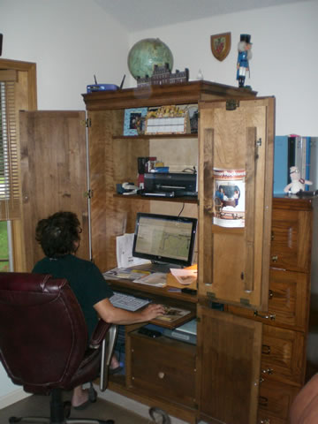

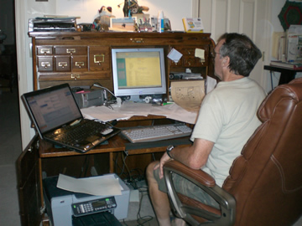
Here we are, already working on the next issue – or maybe just trying to finish up this one.

Have a fun Halloween and a blessed Thanksgiving.

