BUNNELL/BONNELL NEWSLETTER _ Edited by Carole (Guthrie) Bonnell
P 0 Box 1223 - Graham, WA 98338 Assisted by Teri (Beckwith) Bonnell
(206) 847-2357
__________________________________________________________________________________________________
Published to Assist in Sharing Family Records, Research, & Genealogy Vol. 11 # 1
S 12.00 yr. Donation - 4 Quarterly issues January 1997
FREE Queries to subscriber
__________________________________________________________________________________________________
Contents:
Editors Comments & Introduction Illinois: Buckley Cemetery
Queries Direct Line of Members
Suggestions
E-Mail Addresses of subscribers Lineage Chart of Claude Bunnell
Index to Information Received Revol & War 1812 Soldiers Index
Canada: Nat'1 Archives " Newspapers of New Brunswick Member Pegree Charts
1784 to 1883 & Marriage Records 1819 -/ Land Family of Nutall written 1887
Lineage chart Claude A. Bunnel' Obituaries

---------------------------------------------------------------------------------------------------------------------------------------------------------------------------------------------

A Note to the Subscribers of the Bunnell, Bonnell Newsletter -from William R Austin - Past Editor
"Although it became advisable for me to close out my activities as editor of the Newsletter, I hated to see it die. Therefore. I was truly delighted when Carole Bonnell offered to take it over. Carole has already done a loi of research into the family history and has been generous in sharing the results of her work. She will do fine job. I am sure she •will find many ways to make improvements in the Newsletter. I encourage you all to support her efforts as you have supported mine. William R, Austin"
------------------------------------------------------------------------------------------------
From the Editor: As your new editor, I want to thank you for having faith enough, due mostly to the great job William Austin did. to renew your subscription another year. I have been researching many years and have met many very warm and friendly Bonnell and Bunnells while traveling. My husband is the Bonnell in the family and we began our research when his father died in 1986 and in his belongings found an obit from his great grandfather Oliver BONNELL, (who was Oliver BUNNELL, at birth in New Brunswick Canada in 1858.) I became very infected with the genealogy bug and have spread it to other members of my family and friends. We motorhome several times a year, driving one year from Washington State across the US to New Brunswick, Can., gathering information from Canada's National Archives and cemeteries while on the trip, which I will include in future issues for Canada researchers.

We travel about three or four months a year and gather information on the way. We are lucky enough to stop in Salt Lake City, Family History Library at least twice a year, once a year flying with my 'infected' sister in laws, including Teri Bonnell, your membership secretary. I have gathered information on all Bonnells/ Bunnells 1 see in records, as 1 couldn't connect mine until an unknown cousin, Betsy David, added to my chart and Wm. Austin and Claude Bunnell helped me a few years ago. So, I shouldn't run out of information to print for quite awhile. Although, 1 do encourage you to send in your own family information to share - there are probably many "cousins' reading this same paper anxious to share with you.

Thank You!
First of all, on behalf of all of the subscribers and myself, we heartily thank William R Austin, the past publisher and editor, for his 10 years devoted to this newsletter. With (almost all) the subscriptions, come letters praising his work in the past and crediting him with connecting many researchers where they were lost. As the mail piles up on my desk, I have a very real appreciation for the time he spent on this project- It is almost overwhelming} Thank you to all who sent in the 'extra $' for publishing - it is appreciated!!! I also want to thank Claude Bunnell for all his past and future help with his large database and offer to answer our queries with the information he has gathered. They also were helped by contributions by many of you, who are too numerous to mention here. But, know that your efforts are appreciated.

I thank Wm. Austin for his endorsement and for giving me the opportunity to do something I have wanted to try for a long time. Being able to start on an 'already published' newsletter is a big plus. And thanks for all your encouraging letters. I've got big shoes to fill! Below is part of a letter from Claude Bunnell (Send him proven sources)

"I welcome any information that I can add to the data bank (on Bonnell, Bunnell. Burnell). I have developed programs that can produce a lineage chart together with notes and sources by a simple command. In General 1 can provide whatever information is in the database to answer a query and would he glad to cooperate in answering."
Winter: 2110 Harbourside Dr #538. Longboat Key. FL 34228 / Summer; 408 23 rd Str. Ocean City. NJ 08226

(Ignore page numbers. It's a test to see how 'alert' you are. Not really, I goofed! We've also added 2 pages .this Issue )

Exchanging Information:
As I receive subscriptions, there are also letters or queries on different lines. As I find the same names, with the help of Teri Bonnell, sister-in-law, and good friend, who has offered to help me. We will try to alert others tracing the same names in the line and urge them to contact each other for exchanging information. You will see some changes in the Newsletter that you may not think are necessarily better, but different. As different editors are interested in new ideas to be shared, with little space to use, some things will be dropped to add new. We would like to try a few New things, and due to space will have to omit others, such as obits, and marriages unless the subjects were born over 70 yrs. ago. They are interesting, but as I said, we can't print it ALL. We do want to receive the obits and will keep them on file, hoping to make a obit package at the end of the year, or fill in space, if needed. I will send them, by request, to anyone, for the charge of postage and copies.. Please be patient with us and let us know what you like and don't like. We have had many suggestions and I will try to print most and implement some that seem worth doing or were suggested by several subscribers- This is your family paper, we need your input, your research and your ideas.
Please also remember this is new for us and though we have done much research, we've never before written a newsletter, other than our annual Christmas letter, and travel journals, and will make many mistakes. Please feel free to point them out to us (tactfully, please} Throw in an 'Atta boy' once in awhile loo!
Sharing Research Information:
Please send in information gathered. I have been asked many times, but the answer is; I do not have William Austin's files- Though, I am sure, should we have a question, he will be helpful in answering it. It would not be cost effective for him to copy all that be has acquired in 10 years and mail it to me, I am sorry to say. So if you already sent him your information - please also send me a copy.. It would be greatly appreciated.
We all have research we have collected over the years that didn't help us, but may help others in their research. Claude Bunnell, whom William Austin has mentioned many times in the newsletter, has a very large data base full of Bunnells of every spelling that he has collected over the years and has used proven sources, such as birth, death and marriage, etc. He has generously offered to answer queries for us and share his information. He asks that you send him proven sources of Birth, Death, Marriage, etc. also, to add to his research/or sharing with the rest of us. Send queries to me, I will print them in the newsletter and forward them to him. He will send you (and me) a copy of his answer. But.....1he query is for all of us to try to answer and add to. If we can.
He has sent me a packet of Military and Land Index Records for Bonnell/ Bunnells and I will print as much as I can in the newsletter. There will be more than we can print, including information gathered in my own files and information sent in by you subscribers. Wm Austin printed much of the land records in 1996 Newsletter, {for new subscribers info) So, I am going to make room for index to" Research Gathered', in each issue, so you can contact the newsletter, or the compiler of the information. I would like to encourage subscribers to contact each other and share information. There is an enormous pile of gathered information in our (we researchers) files that did us no good, but may be a major breakthrough for someone else.

Suggestions:
We will try to leave room for suggestions sent in by subscribers. It will let the rest of us know what is of most interest and hopefully we can add to the newsletter with our research. Please feel free to send in Suggestions and ideas for the newsletter or Helpful Hints for researching, (keeping them brief)
Queries:
Will be FREE to subscribers and printed as room permits, in the order they are received, per issue.. To non-subscribers, the cost will be 10 cents a word, with $ 4.00 minimum. Please make your question clear, with as much information as you have to help answer your question - such as who married who, when, where. Also helpful to add middle names or initials and nicknames. ALWAYS include the State & County, if known. And still making it brief enough to allow room for others. As time permits, I will be sending your queries to Claude BUNNELL, as he has offered to check his data base, and will include your query, and his answer in the same issue - but.... anyone having more information is encouraged to answer it also, mailing your answer to us & author. Please include SASE if you would like a reply instead of waiting for the next issue.
Mailing List & E-Mail: I would like to send out a mailing list of subscribers, to include Computer E-Mail addresses.. If room in the newsletter or on request by members at the cost of printing and postage. ( 30 cents plus Stamped Self Addressed Envelope as of this mailing. This would only be for genealogy use, as a tool for research and NOT for a * commercial mailing list for anyone to profit. E-Mail addresses will appear as I receive them in the Newsletter.
Anyone NOT wishing to be published on this list, and sent to other Bonnell/ Bunnell researchers, you should contact me. If I DO NOT hear from you, by March 15. I assume it is okay to put you on the list for others to contact.

Pedigree Charts
If you have a Bonnell/ Bunnell, Burnell, all spellings, in your line. please send me your pedigree chart to add to my files and 1 can shrink them down and print some each month in the newsletter. Since we aren't all up on geography - please also add the state, not just city and county when sending in ANY information to the newsletter. Be sure to put your name & addiress on ALL pages sent to us. The only way there will be room enough for all we wish to be included, without raising the cost of the paper, is to shrink some of it down before printing, If it is too small, take that page to a copy center and have it enlarged - or complain to me, and we will put less in the paper. But please send in the charts for my files.
Misc.
Information of interest to the majority of us is welcome. Are you publishing a book on a Bonnell/ Bunnell line? Did you find a new research tool, unknown to most? Are you having a Bonnell reunion and we're invited? (We do not have space in the
newsletter/or reunion information except to give basic, date. place, time, etc. of event.
****
QUERIES: Jan. 1997
Queries are FREE bo subscribers. (10 cents a word, $4 minimum for non subsc.) Keep them brief, they will be published as received and as room permits. Claude Bunnell will be sent all queries to check in his database, but we want readers to also add to the answers here. Please feel free to write the addresses at the end of the query or the newsletter with your reply.
1. ARMSTRONG. BUNNELL. GRAVES. SPRAGUE:
Claude (or anyone else) Do you have anymore information on my Daniel BUNNELL Jr. (and Sr.) who married Emma SPRAGUE and his son Daniel BUNNELL Jr. who married Emma GRAVES, dtr of Emma ARMSTRONG. Daniel and Emma (Graves) BUNNELL had Alfred Murray BUNNELL 1833 NB, Canada- (our line: William, Benjamin, Benjamin, Gershom, Isaac, Daniel. Daniel Jr, Alfred M. Bunnell, Oliver H. Bunnell/Bonnell, Burt K. BonneD, Larry (my husb.) Bonnell.)Carole Bonnell - 22717 41 AVE CT E - Spanawayv. WA 9S387-6925
2. BUNNELL, WOODBURY
We are stopped & stuck with Edwin Fairbanks BUNNELL. b 25 Sept 1807 Hartford, Hartford, CT. d. 11 Dec. 1891 Oakland; A. Calif, mar. 3 May 1833 Francestown, H. NH. Adeline, D. WOODBURY b- 22 Apr 1809 Francestown, NH, d. 8 Nov 1897 Oakland, Cal. child: George Woodbury BUNNELL b. 25 Feb. 1840 Roxbury Suffolk, M.d.6 Jan 1926 Oakland, Cal. mar. 31 May 1862 San Francisco, CA Alice Theresia BAKER, (chart included in newsletter) Alice D. Gedge. 2201 W. 13400 So.. Riverton. UT 84065.
3. BONNEL. McGRATH
I need the names of parents of Joseph BONNEL, b. 1783 in VA. He married Martha (Patsy) McGRATH, b. 1796 in VA. they mar. in Jessamine Co, KY in 1813 and later moved to Howard Co, MO. Any info on her welcome. (Mr) Gayle F Bonnell. 582 Huntington Ave. So. Castle Rock. WA 98611
Claude: I examined the census indexes for Jessamine Co, KY and found the following ref. that might help. 1810 McGrath. Briani FS5 00100-10100 1820 McGrath, Lawrence FV6 need orig. mf.
Terrance F53 21210-11100
4. BONNELL-
My primary interest is in gaining information which may lead to the identification of the ancestors of David BONNELL ca. 1792-1880+. We have been unable to determine who David's parents were, where he was born (KY or VA, which may be one and the same) or where and when he died. David BONNELL was my gr-gr-gr-grandfather on mother's side. Mariorie C Gibbs - 89899 E. Escalante, # 446. Tucson. AZ. 85730-2899. (aflerApr I5. write PO Box 55. Union Springs NY 13160-0055
5. BONNELL
My mothers name was Bonnell, her father Franklin Pierce BONNELL, grfa; Alien BONNELL (French Accent). Need to
clarify Alien's ancestry. Any research on this line? Jewel! B Butler-78/8 Newc oDr.. Hamlin. NY 14464
6. BUNNELL. BERRY. JAYNE.
My interest is primarily in the earlier gen. of the BUNNELL family, being a desc. of Benjamin BUNNELL (1742) and Catharine BERRY. Their dtr Polly (Mary?) BUNNELL mar. John JAYNE, son of Capt Timothy JAYNE, on 26 Nov 1815. John's bro William mar. Elizabeth BUNNELL, Polly's sister, and his oldest bro. David, mar Polly BERRY, younger sister of Catharine. this leads to a rather strange relationship of an aunt being the sister in law of two other nieces. To compound matters, I am desc. of both John and David JAYNE, my parents being 3rd cousins. Towner Javne - 304 Powell Ave SW, Renton. WA 98055 any other of these lines?

7. BONNELL. GABLE/GOBLE. HOGAN. JOHNSON
My line I was researching was from Erie, PA, Waterfbrd areas; B-l CB 004113 John BONNELL, b 1753/1757. was Revol. Soldier and I would like to verify this. He was listed as buried 1845 Erie Co, about 15 miles from Erie at Waterfbrd, PA or maybe at an old cemetery that was called BONNELL Cemetery. Located at corner of Donation and Strong Rd. My connection to John is thru 6 th child of Wm and Mary Eliz. (HOGAN) BONNELL - their son William Harrison b 1818 mar Eliz. GABLE or GOBLE and moved to Rosendale, Fond du Lac, Wise. Their 2 dtrs, Emily and Nancy moved to IL about 1850. Nancy mar. George Washington JOHNSON from, I believe VT. She was my GR GR Grandmother. Lorelia M. Brasche- 1115Beecher. Galesburg, IL 61401
Claude: Am sending you pc of Johns as soldiers serving in the Rev. War from the Nat. Archives. He may not he in this list unless he might be Matrass Bombardier. I have some confusion in my records on the child: of #4113 John Bonnell. The encl. printouts list a 012461 William. son of lohn. According to Harry L Stephenson Sr.. Author of "History of Little Pine Galley" (Lycoming Co. PA) 1992. the child: of this Win are Elizabeth. George, Nancy. Sarah, Susan. John. Catherine. Mary. and Benjamin (no dates given) A second printout lists William H Bonnell h. 1818 PA. His father ims 004550 Willis according til the 1830 census for Waterford 'I'wp. Erie Co. PA. Could Willis be an incorrect reading of William? Note there was not a William listed in the children of 012461 Wm. I would appreciate any infor. you might offer to add or correct my files.
8. BIDDLE. BUCKLES. BUNNELL. DICE. FOUTS, GILLILAND. MILLER
[ am searching for the parents of MARY ANN BUCKLES, b. i Sept 1809 in Ohio and became the 2 nd w/o Barton BUNNELL (s/o David) in 1829 after his 1 st wife (Ann BIDDLE) died. They lived in Waynetown .Montgomery Co, IN. as did two of their children: Veasy, b.29 Oct 1835, who mar. Mary A., and Sophia, b. 1838, who mar. John FOUTS in 1854. Their oldest son. Barton, JR- mar. Melinda DICE, the youngest dir of Frederick and Catherine (MILLER) DICE, b. 1835 Fountain Co, IN. Barton JR and Melinda BUNNELL moved to Rossvitle, Vermilion Co., IL. where three children were born, and Barton d. 1863. Melinda mar. Samuel GILLILAND in 1871. Any info on anyone mentioned or their desc. would be greatly appreciated. Hope to hear from anyone related to David BUNNELL and his son, Barton. Linda L. Doty -1881 Sorrel Lane - Gardnerville. NV 89410
Claude: Do not know parents of Mary Ann Buckles, but have l.DS IGI, Anc.flle in my office & find no Mary Buckles thai match, sending printouts of ref. in Ansc. file. From the census records of 1830, 1840 and 1850 my # 320293 Barton b. 1799 showed 9 child:. 5 w/ 1 st wife Ann and 4 w/2 nd w. Mary. [have identified only Stephen J. James, Barton. Veazy, and Sophia- Might you know the names of the other 4 children and date of birth?
9. BONNELL. BROTHERTON. BURNELL. DORN. FOGWELL?/SHATZER. GLASSBURN. PEARSON.
I'm seeking information on Aaron BONNELL and his Conn, & NJ families, parents supposedly Benj. & Eleanor BONNELL. Aaron BONNELL b.30 mar 1749 mar. 12 Apr 1772 Morris Co, NJ Ann BROTHERTON b. 7 Sept 1753 = Henry Bonnell b. 29 Ju! 1775 mar. Ont. Can, 4 Feb. 1801 (Quaker) Margaret BURWELL, = Aaron BONNELL b 3 June 1807 mar. Ont. Can., 1835 (Quaker) Lydia Ann PEARSON b. 12 Jul 1812 Can., = Joseph Pearson BONNELL b. 22 Jul 1848 Oakwood, Victoria Co, Ont., Can. mar. Ft Wayne. IN. 11 Nov 1879 to Frances Ann FOGWELL nee SHATZER b. 7 Apr 1857= Edna May BONNELL -Ellen Dorn - 209 41 st Str - Manhattan Beach. CA 90266-3140
10. ALLEN. BONNELL. BUNNELL. MILLER. MINTURN. SEARING. WHITEHEAD. WILMOT
My Bunnell line is: William BUNNELL & Ann WILMOT, Nathaniel BONNELL & Susannah WHITEHEAD, Nathaniel BONNELL & Mary SEARING, Nathaniel BONNELL & Joanna MILLER, Nathaniel BONNELL & Elizabeth ALLEN, Abigail BONNELL & Jacob MINTURN (?), etc. - 1 am interested in all the female lines through the four generations of Nathaniel BONNELL. Margaret (Hendrick) Gardiner. 417 E. Monroe Str. Morton. IL. 61550-2127
11. BONNELL. GARRABRANT
I'm looking for the parentage of my great, gr-grandfather, Charles Pickney BONNELL, b 5 May 1802 at Mendon, Morris, NJ, d. 10 Dec 1876 Point Bluff, Adams, Wisconsin, mar, Jane GARRABRANT 26 June 1830. His father may be Charles BONNELL, son of Lt. Col. Abraham BONNELL, but we have no records to support this. Appreciate, hearing from anyone who has any info. that would help me. Thanks. Rulh B. Seaver. 1865 W. 350 N.. West Point. UT 84015
12. BONNELL. BROADWELL.
Sarah BROADWELL mar. James BONNELL abt 1731. Who were her parents and siblings? Grandparents? Source
information? Kav Ohana 5020 San Marque Cr.. Carmichael. CA 95608 E Mail kohana@pacbell.netl
•
13. Do you know the history of MT BONNELL Austin, TX - Walter BonnetI 1443 White Ash Dr. Columbus, OH 43204
14. BONNELL. EGBERT. McCALL
I had an uncle in So. Bend. WA; John BONNELL, b 15 Mar. 1874 d 9 Feb 1941; son of James P and Mary Elnora (EGBERT) BONNELL; wife Izora McCALL both of Fulton or Pulanski, IN. They had a son Hershal Divon whom I met in the early 1930's. Do you have any data on these people? Fd like to complete the record of James P BONNELL's children, one of whom was my father. Also need data on John's brother William, Topeka, KA. James P Bonnell - 2968 Bedford Dr. Merced. CA 95340
Claude: I have over 35.000 Bonnell. Bunnell and Burnell individuals in a database format. I have printed out the info in my database that pertains to your ancestry. Send me any additions or corrections.
15. BUNNELL
As of this date, his children nor his sisters or any relative knows if my uncle, Everett BUNNELL is dead or alive. We would all be interested to know. His parents were; Lucy Mae & Bert Levi BUNNELL. He was b. Ohio. In the late 1940's he moved to AL, then back OH. then he moved to FL and no one, not even his children have heard anything for years. Can anyone help? Phvllis Brunk - 302 Hill Haven Dr.. West Carvollton. OH 45449
I wrote: contact the Soc. Sec. Admin for his SS Application, and try Salvation army for living relatives then sent to Claude. Claudes reply: The Social Security Death Records. Everett d. Apr 1981 in St. Petersburg FL. His SS# 301-03-4965. You can obtain more info by contacting SS Admin. in WA. I have Everett's Ancestry to WM. Bunnell the immig. if you wish it. I have no record of any children for Everett.
16. BLOCK. BONNELL. COLE. MADDEN. MILBURN, MORGAN, SEVERNS
As far as I know no one has determined the parents of Isaac BONNELL, Sr. b. 1755 NJ (?) d. 1834 OH. mar. Catharine SEVERNS b. MD? d. 1839 OH. and that is of prime interest to me. His son Jonathan b. 1785 NY? d OH mar. Ruth MILBURN = son Jonathan Milbum BONNELL b. 14 Nov 1825 Guernsey Co., OH, who mar. Eliz. MADDEN, child:
Frances Josephine BONNELL b. 1860 Sidney, Champaign Co, IL., d. 9 Oct 1897 Sidney, IL.. Frances mar. 18 Feb 1877 Sidney, IL. William Harrison HARRIS b. 16 Aug 1846 Harmony Clark Co, OH. (2 nd mar. Mary Margaret MORGAN) I would be interested in exchanging info with other desc. of Isaac BONNELL, Sr. I desc. from J.M. BONNELL & Elisabeth (MADDEN). Elaine V. BLOCK Cole - 4508 Hawk Court. Dale City. VA 21193 (703) 590 4194 E-Mail:
evbcole@aol.com (she has included group sheets and charts).
Claudes reply: The only records I have on Isaac BONNELL 175x - 1834 are published records such as census, vital, probate, deeds and co. histories. Please brief me on the list you included. (1. wife Catherine maiden name of Severns. 1 have not seen an origina/ record for her maiden name. 2. Birthplace of Frederick, MD. The census records indicate Isaac JR was b. VA and I have not seen the 1810 census for Louden Co, VA that you referenced. I show Isaac Sr. in Wayne. Twp., Crawford Co. PA in 1810. Have you any records for Frederick, MD in the 1800 to 1830 range?)
ED; Can anyone else help with this linv?
17. BQNNELL. LACEY
I am trying to find information on Marcus Eggbert BONNELL b. 17 Aug 1816. when did he die? His wife was Jane LACEY. Need her birth and death dates. Their children: Amelia N. BONNELL b. 1838 Newark, NJ. and Joel M. BONNELL b. May 1844. His wife was Mary. This couple was living at 30 Sixth Ave., Newark, in 1900. Their Children were Fred and Grace BONNELL. Apprec. any info on them. N. Lynn Trelles-Gaines. 3830 Lake Str. Houston. TX 77098-5324
Claudes reply: Have record in database of Joel M BONNELL b. 1844 wife Mary. He had several children as indicated in printout sent you (by Claude) No further info on his desc: or children of Frederick. Would appreciate receiving anything you can add to this line.
*****
SUGGESTIONS sent to me;
(Keep in mind we only have 14 pages every three months to fill at the present.'subscription rate )
Shorten the obituaries, they take up too much space - my needs are research on back or people researching the same line. Althea Statum. Catoosa. OK. (Ed note: at this time we are trying to only print obits of 70 yr. olds or more. filing the rest for members use).. I hope there will be more queries & answers to family research problems, I believe we all benefit from this. Loreiia M. Brasche. Galeshurg. IL. (Ed note: there will he - with subscribers help)
I would like to see listings from country records of all Bonnell & Bunnell Marriages. Birth & Deaths that are indexed, that you might be able to collect from County Clerks or Genealogical Societies. My effort is concentrated on collecting original records. Also I would like E-Mail addresses of subscribers, mine is cbunnel@ibm.net - Claude A Bunneil, 1110 Harbourside Dr # 538. Longboat Key. FL. 34228 winter. Summer address: 408 23 rd Str. Ocean City. NJ 08226 (Ed note: Head to your files and local sources guysl)

Historical and analytical articles are the most helpful & interesting. Continue with the oldest of the families, more "name" analysis like Benjamin & Nathaniel. Queries are good! Claude and Bill should contribute from time to time, maybe some of the other authors, e.g. Ruth Duncan. Jerome Hatch - Chicago, IL. (Ed. note: Please explain more. - and send in Historical items, Ruth Duncan says she is not doing anymore Bunnell research, but we would welcome her input, Claude is answering queries and sending me recorded info - we'll give Wm Austin a short break to rest up, but his comments and suggestions are welcome anytime)
I would like to see issues devoted to concentrating on a particular area or time frame. For example, in your Jan issue you could announce that the April issue will focus on Monroe Co., PA. and invite everyone to submit material (you could be overwhelmed) Monroe Co from 1840 to 1900. Anyway, that type of approach might serve to connect researchers who have an interest and material in a certain area. Just a thought. Charles E. Bunnell - San Anionio, TX - E-Mail: kxgj68a@prodigy.com (Ed nole: we are encouraging EVERYONE lo contribute what they are interested in each issue - This is a Great idea, hut the size of the paper doesn 't give enough room/or a state or county issue. Please send in or put a query about the area you are interested in - the earliest info will gel printed, if room)
Teri Bonnell, membership secretary and assistant suggested that our annual trip to Salt Lake City. Utah in October we devote one day to Bonnell/Bunnell research/or the Newsletter, I agreed. Any 'small' requests out there as to area of search?
Ed Suggestion: Share your copy with your local Library, Genealogy or Historical Society, if they don't receive it - You are welcome to make a copy of the paper - this is a not for profit paper to help gather family information - the more circulation, the better. At this time. Jan 1997 forward, it is not copyrighted by me..... ****
E-MAIL ADDRESSES; (send yours in)
Charles R. Bunnell - TX - locgj68a@prodigy.com Claude Bunnell - FL - cbunnel@ibm.net
Betsy David - VT - bdavid@together.net KayC Ghana -CA - kohana@,pacbell.nel
INFORMATION RECEIVED-.
Much information that is receive is too immense to put into the newsletter - one file would take the whole current quarters pages (about 14 each qtr). So we will list the information, print some of it and if interested - ask for names or a copy of each file paying 10 cents a page and postage costs. Please always send Stamped Self Addressed Envelope when requesting into from ANYONE.

from Claude A Bunnell
Deeds Index - Essex Co, & Morris Co, NJ (8 pages ea) Mortgages Index - Essex Co, & Morris Co, NJ (3 & 4 pges)
Civil War Service Records (both Union and confederate) (9) Revolutionary War Soldiers Records (2)
War 1812 Soldiers Records (2)
Spanish American War Soldiers Records (1)
War Service Pension Index 1861 - 1934 (10 pages)
He has collected original records of the above lists and wishes to receive copies of any records from subscribers.
Carole Bonnell
CANADA - New Brunswick, census, Marrige, Death, Cemetery records from FHL Salt LK C. films & books.
Kay Ohana - her mothers records (56 pages)
Pedigree charts - Thomas, Benj, Wm Bunnell (immig), Nathaniel I, Nathaniel II, James, Jemina Bonnell b. 1744 NJ
Bonnell pt of book of Harty & Meador by Mary P. Harty Welch
Group sheets beginning w/ Thomas Bunnell of France & Engl.
Robert E. Dlls (15 pages)
Pedigree charts - Wm, Wm (immig), Nath , Nath, James, Mary Bunnell b. 1743 & Benj. Blackford
John E. Bunnell
Family record from William the immig to self b. 1923 (6 pages) Wm, Benj, Benj, Solo, Isaac, John, David, jams S. David J. Granger Ernest Bunnell, James Ernest Bunnell. b. 1923

CANADA (info typed all as it was recorded -if a name rings a bell, check out that County of NB Canada for more info)
Provincial Archives - New Brunswick, Canada - research gathered by Carole Bonnell 9 Oct 1994 BUNNELL - Kierstead Histories 1-2-3
Gershom BUNNELL and wife were members # 62- 63 Congregational Church ot'Redding, Ct., from "Manual of The Congregational Church of Redding, & Congr. Church of Redding,Ct", & "New Haven Ct 1896" by John w. Hunn Co.
RS108 - Land Petition index 1783 -1918 A thru F
BUNNELL, Alfrcd - Albert Co. 1859 film 9,019 (copied - is Alfred Murray Bunnell son of Daniel Bunnell Jr.)
Vital Statistics from New Brunswick (Canada) Newspapers; Vol 1-2-3 1784 - 1828
BUNNE, Gershom Esq. - 29 Mar 1817 -Sunbury Co, Admin. for Est. Silvanus Plumer, Sheffield
BUNNELL, Isaac - 12 Mar 1822 - Administrator for Estate of James DUGAN, Sussex Vale, along with Ezekiel Foster, & David Keirstead (Jerusha Sherwood Bunnell married James Dugan after death of her husband Isaac Bunnell)
BUNNELL, Benjamin - 17 Feb 1828 died Long Beach @ 84 vrs C. G.
BONNELL, Isaac - 2 July 1830 - Courier Nspaper - Mary (BONNELL) WOOD died NY dtr of Isaac BONNELL, wife of Isaac WOOD - Annapolis, Nova Scotia NBR.G
Vital Stats - Vol. 7-8-9 1837-1841 & Vol. 10-11 1842-1847 Vol. 14-15 = 1852-1856 Vol. 16-17=1856-1859 BUNNELL, Lavinia - 5 Feb 1846 - wife of Gershom BUNNELL died at age 85 (or 35 hard to read) yrs.
Camada.(cont.)
BUNNELL, Isaac -12 Mar 1822 - Administrator for Estate of James DUGAN, Sussex Vale, along with Ezekiel
Foster, & David Keirstead (Jerusha Sherwood Bunnell married James Dugan after death of her husband Isaac Bunnell)
BUNNELL, Benjamin • 17 Feb 1828 died Long Beach @ 84 yrs C. G. BONNELL, Isaac - 2 July 1830 - Courier Nspaper - Mary (BONNELL) WOOD died NY dtr of Isaac BONNELL, wife of Isaac WOOD - Annapolis, Nova Scotia NBRG

Vital Stats-Vol. 7-8-9 3837-1841 & Vol. 10-11 1842-1847 Vol. 14-15 = 1852-1856 Vol. 16-17=1856.1859
BUNNELL, Lavinia - 5 Feb 1846 - wife of Gershom BUNNELL died at age 85 (or 35 hard to read) yrs.
BUNNELL, Alfred - married by Rev. Matthew Smith, Sussex (Kings Co) to Miss Lucinda GRAVES of Elgin (Albert Co)
BUNNELL, Benjamin - Thursday 18,1858, - his wife Sarah BUNNELL d. Westfield (Kings Co) @ 68 yrs Funeral 10 am
BUNNELL Daniel - 28 Nov 1858 - Sussex P. Kings Co, married Albert Co, to Ann STEWART, same place

VitalStats -Vol. 18.19 1859-1862. Vol. 22-231864-1866. Vol.24-251866-67.Vol. 261867-8. Vol. 27-28 =1868-70
BUNNELL, Isaac - 21 Jun 1860 - died @ 79 yrs - Queen Co, 8 m inst.
GRAVES, Emma - 23 Mar 1866 - d. Hampton Village (Kings Co) @ 100 yrs, relict of William GRAVES - Upper Sussex
BUNNELL, Benjamin - 14 Aug 1866 d. Westfield (Kings Co.) @ 78 yrs
BONNELL, Anna Maria -16 May 1862/6 - d. at res. other son in law T. R. WETMORE, Esq. Gagetown (Queens Co) @ 81 yrs. relict ofW. F. BONNELL
BUNNELL, George -1867 • Mar 20 Nov? by Rev. E. C. Cady, Lancaster (St John Co) to Miss Abigail Jane MARKS of Carlton (ST John Co.)
GRAVES, Charles Sr. - 7 Feb. 1868 d. @ 84 Gotion, Elgin Parrish (Albert Co) at sons. res. He was bapt. at 20 yrs UNI. Bapt
GRAVES, Charles W. - 21 Jul 1868 (Visitor Paper) Charles of Albert Co, who married Harriot CLARK by side W. W. CRANDALL. He left 9 children, 51 Grandchildren, 31 Great Grandchildren.
BONNELL. Grieves - Jun 1868' d. Sunday while living in Upper Fredricton (York Co) under suspicious circumstances. An inquest was held before Dr. Dow, Coroner = Verdict; Committed Suicide by person. The deceased had purchased a quantity of arsenic a few eves previous for avowed purpose of killing rats.
BONNELL, Benjamin - 10 Jun 1870 - listed as a rate payer of Fredricton (York Co, Can)
BONNELL, Sarah - 26 Jan 1870 - daughter of Benjamin BONNELL, married B. R. SEGEE by Rev. Joseph McLEOD at res. of minister.
BONNELL, Viets Esq. -22 Sept 1869 - married Helen, adopted dtr of James GEROW Esq. of St John city. Viets BONNELL of Brooklyn, NY mar. at St John Church - St Marks rector Rev. George M. Johnson performed the ceremony.
GRAVES, Tobias - Jan. 1869 - married Eliza Ann HAYWARD ofGoshen dtr of George HAYWARD, Albert Co,
GRAVES, Margaret A. - 1 Feb. 1869 - married Isaac N. PERKINS/ PARKER. She is the dtr ofWm GRAVES. Wesleyan Parsonage. Petitcodiac Station by Rev. Allexander McCulley of Elgin.

Vital Statistics from New Brunswick Canada. Newspapers: Vol. 29-301870-71. Vol. 31.32 1871-72. Vol. 33-34 1872-73
BONNELL, Annie May - 5 Aug 1870 - Friday, died @ 10 weeks - dtr of Annie P. and Samuel BONNELL
BUNNELL, Ruth Ann - 25 Jun 1871 - married James G. LANGLEY (Queens Co) Cumberland Bay.
BUNNELL, Timothy J. - 24 Dec 1870 - son of Timothy J. BONNELL drowned. Amherst Gazette says a young man was drowned at Shinimicas on Xmas Eve said to be T J BUNNELLS son-
BONNELL, Abigial J. - 8 Apr 1873 - married William LESLIE of Lancaster (St. John)
BONNELL, Kate - 24 Apr 1873 - married Thomas VIALL (St John Co)
BONNELL, Simon -31 Jan 1873 - his dtr Mary Jane BONNELL married David McCORDOCK (St John)

Vital Stats NB Can. nspr Vol. 35-36 1874-75. Vol. 37-38 1875-76. Vol. 39 1876. Vol. 40-41 1876-77. Vol. 42-43-1877-78
BUNNELL, Isaac - 11 May 1874 -his son drown Oromocto Lake
GRAVES. Charles A. - 9 May 1875 -his youngest dtr of Elgin, (Albert Co), Tillie GRAVES married (St John) to John F. STEADMAN, grocer.
BONNELL, Frank -12 Dec 1874 - obit appeared in Digby Courier. Frank "Rises' to explain he is still Alive!
GRAVES, Emma - 21 Sept 1876 - roamed in Sussex (Kings Co) by Rev. James Gray to John McKenzie of Elgin (Albert Co) she is the youngest dtr of Emma and William GRAVES of Elgin (married John McKENZIE of Elgin (Albert Co).
BONNELL, Capt. Simeon - 24 May 1876 - his youngest dtr Charlotte married at res. of parents Adelaide Rd, Portland, (St John Co) married Alfred L. COWAN.
BUNNELL, Olive - 4 Oct 1876 - married Sussex Vale (Kings Co) of Wards Creekto Charles Henry CLEAR
BONNELL, Fredriek S. -12 Jul 1877 -married at Portland (St John Co) Martha L RITCHIE eldest dtr of Francis Esq
BONNELL, H. A -19 Jan 1877 - news article: At Anagance Station (Kings Co) there is a large store, kept by Isaac FREEZE and Mrs George ARNOLD keeps a millinery and dry good store. Merritt GRAVES and H. A. BONNELL, manufacture first class boot and shoes. There is a hotel, kept by B. KINNEAR and the spiritual welfare of the people is looked after by Rev. S H WEYMAN, Free Christian Baptist minister. There is a public hall and school about half mile • from the station, Mr, C T LEWIS is the station agent and post master and telegraph operator. There is a lodge of British Templars now in a flourishing condition- There are a number of Anagance teams in the woods this summer.
GRAVES, Charles Wesdey - 31 Jul 1878 - married Sussex (King Co) Alice Elizabeth BELL, dir of Alexander Bell. Upton
NB Canada (cont.)
GRAVES, Esther - 30 Sept 1878 - widow of David GRAVES d. @ 87 yrs at Port William.
GRAVES, Augusta - 31 Oct 1878 – of Havelock, married Tangore PRICE of Salisbury (West Co).

Vital Stats NB Can Newspapers. Vol. 45-46 1878-79 Vol, 47-48 1879, Vol. 49-50= 1879-80 Vol. 50-56. Vol 57-58 1881-83
BUNNELL, Alfred L. -12 Jan 1878 - married Mabel DALTON, eldest dtr of Henry DALTON, Esq.of Indiantown. (St John)
BUNNELL, Mary - 18 Feb 1879 - married Sussex (Kings Co) to Alexander GIRVAN of Wildford (Kent Co)
BUNNELL, William F Esq. - 4 Oct 1879 - dtr Annie R. married ill Brooklyn, NY Charles R. W WARDLAW, at St Peters Ch
BUNNELL, Adelia - married at Baptist Patronage, Moncton (WestCo) by Rev. G. 0. GATES to George SHAFFER both of Moncton, {Ed: dtr of Alfred Murray BUNNELL & Luanda GRA VES)

"American Marriage Records before 1699" (both mar. New Haven C'I)
BUNNELL, Mary & Eleaser PECK - 31 Ocl 1671 BUNNELL, Nathaniel & Susan WHITEHEAD 3 Jun 1665

Kings County Marriages - New Brunswick CANADA
Register B. # 2699 - Daniel BONNELL, parish of Studholm/ Margaret McLANE, parish of Sussex, 4 April 1854. Wit: Daniel McLEAN (note difference in spelling), Rachel Ann McLEAN..
# 2699 - N. B. - Alfred M. BUNNELL, parish of Sussexx / Lucinda GRAVES, Elgin, Albert Co, 16 Jan. 1854. Wit; Judson GODDARD, George HAYWARD
# 3675 - Daniel Graves PERRY, Greenwich / Mary Elizabeth BUNNELL, Westfield, 21 Feb. 1866. Wit: Henry P. HARVEY, Susan BUNNELL.

Kings County Marriages -NB Canada (LDS Film# 1,429,644)
BUNNELL, Isaac, Co of Queen, a carpenter mar. Eliz. BLACKNEY, w/ parents consent. Wit: William FAIRWEATHER & John McLEOD June 24,1819
BUNNELL, Isaac & John INNIS witness for Richard ROACH, Sussex, & Etiz. McLEOD w/ consent of parents. Nov 17,1819
GRAVES, Daniel & Anne SPRAGUE of Suxxex - King CO, he is Yoeman. Wif George MORTON & Tilus STONE Dec 12, 1819
BONNELL, Jerusha & Jacob MIRES of Waterborough a Yoeman - Queens Co, her of Springfield, King Co, consent of Parents? Witness: Gillian ? DYKMAN and Isaac BUNNELL Jan 28, 1822
SHERWOOD, John of Norton, King Co, a Yoeman m. Eliz. BUNNELL -Wit: Alexander DICKIE & Machael GILLIES? June 4. 1822
BONNELL, Joseph of Westfield, King Co, Bachelor m. Sophia WARD in Westfield. Wit: John TROTT & Peter Fisher (? date)
WILMOT, Susan H. witness to Mar. William LOGAN & Martha FLEWELLING Aug 25,1823
BUNNELL, Sarah Anne - Parish of Hampton, King Co. mar. Gabriel FOWLER Jr. Mar 14, 1830, Wit: Daniel FOWLER & William WETMORE.
BUNNELL, Isaac, and Isaac PITT witness to mar. of William LAWSON & Eliza P1TT Mar. 16, J 830
BUNNELL or BUNNETT, Sarah to Daniel BACON June 24, 1830
BUNNELL, Mary Jane of Hampton m.. Robert FRENCH - he ofWestfield, Jul 23.1831 wit: Thomas BALYEA & Joseph FRENCH
BUNNELL, Emma of Sussex mar. Daniel GODARD - Wit; Wm Stone May 26,1831
BUNNELL, Eliz. of Sussex m. LaBaron GRAVES - Wit: Samuel John MORTON & Daniel BUNNELL, Jr. Jul 18,1831
BUNNELL, Isaac of Greenwich m. Lavinia KIMBELL. parish Wesfield - Wit: H. M. (?) & Wm BUNNELL/ BUKEIL? Dec 28, 1831
BUNNELL, David of Suxxex, a fanner mar. Emma GRAVES by Oliver ARNOLD, Wit: John LaBaron GRAVES Aug 21,1832
BUNNELL, Simeon ofWestfield m. Purdence CRABB dtr of John CRABB - Wit: John CRABB &. Charlotte HERTNGTON Apil 6, 1834
BUNNELL, Lucy of Sussex m. John WALTERS of Sussex ' Wit: Daniel GODARD & William WHOLPEY (?) Sussex 20 Nov 1834
BUNNELL, Justus m. Margaret BAXTER (sign X) Kings Co., Wit: John KIERSTEAD & George CRAWFORD Jul 22, 1838/ Feb 22
BUNNELL, James & Mary LINGLEY - Wit: For Henry LINGELY & Eliza STEVENS, par. Westfield, Kings Co., 11 1837 ARMSTRONG, Emma mar. James RITCHIE 1839, Wit: Edward ARMSTRONG & Isabellc ARMSTRONG of Portland Co of St John
BUNNELL, Isaac - Witness to : Francis HIGGINS & Anna KIMBLE, Westfield, May 6, 1838
BUNNELL, Justus Johnson m. Mary Jane CHAPMAN w/ consent ofStodholm, King Co., Wit: Isaac B. COY & Stephan CHAPMAN 'Dec 9, 1847
BONNELL, Daniel m. Margaret McLEAN (LANE) of Studholm ofSuxxex. Wit: Daniel McLEAN & Rachael Ann LEAN? (?date)
BUNNELL, Alfred M. in. Lucmda GRAVES of Elgin Co of Albert - til Sussex Co of King, Wit: Judson GODARD & George HAYWARD Jan 16,1853
BUNNELL, Ruth m. Charles DODD of Sussex, Kings Co. Wit: Daniel BONNELL & Margaret McLEAN Apr 12, 1853
BUNNELL, Jemina of Studholm m. Wanamaker, James H. of Norton Parish, King Co. Wit: Thomas WALKER & Frances T. GRION ? Aug 1, 1852
BUNNELL, Mary (sign X) of Westfield, King Co, m.Robert PORTER of Carlton City of St. John Wit: James SOGUE & Affe Jane BUNNELL Nov 12,1856
BUNNELL, Almira m. William PARKER of Westfield, King Co., Wit: Henry F- CRONK? & Savinia (Lavinia?) I or T BUNNELL
BUNNELL, Isaac & John HALLETT Wit: to Hugh ELLISON of Sussex & Jane AUSTIN wed.

Marriages - Kins Co. IS60-69/ 1870-76 (LDS film # 1.508.594 BUNNELL, Emma & James MORRY -1870
Land Petitions Index RS10S - 1783- 1918 - Provincial Archives of New Brunswick.Can (name, petition of, Co, Date, film #)
BUNNEL. Alfred - BUNNEL. Alfred AL - 1857 - F 5935 BUNNEL, Benj. BROWN. Titus - KI - 1785 - F 1024 BUNNEL, Daniel - BUNNEL, Daniel WE-1817-F 4179 BUNNEL, Justus EDGAR, Wm -QU 1828-F 4211 BUNNELL, Alfred BUNNELL, Alfred AL -1859 - F 9019 BUNNELL, Benj PERRY, Win. - KI 1785 - F 1028 BUNNELL, Benj. FRENCH, Joseph KI- 1804-F 1043 BUNNELL, Daniel BUNNELL, Dan'1 K] -1851-F 4241 BUNNELL, GeorgW BUNNELL, George W QU - 1853 - F 4246 BUNNELL, Isaac- Millstm, Sussex Vale KI 1804 F 1043 BUNNELL, Isaac BUNNELL. Isaac KI - 1850 - F 4239 BUNNELL, Isaac W. BUNNELL, IW QU 1855 - F5931 BUNNELL. Justus COREY, Thomas QU 1823-F 4194 BUNNELL, Justus I BUNNELL. Jl KI 1824 - F4196 BUNNELL. Titus BUNNELL, Titus KI - 1842 - F 4223 BUNNELL, Titus PURTELL, Patr. KI 1853 F4247
BUNNIL, Gershom BUNNIL, Gershom SU- 1819 -F 4183
ILLINOIS:
Christian County, Illinois - Buckey Cemetery - Locust Township Section 32.
Buckey comprises an acre of land located in Locust township, three miles south and two miles west of Owaneco, IL. It is kept in excellent condition.
Early settlers from Ohio came to this place in 1852 naming it Buckey Prairie for thcir native state. They organized a religious society about 1866.
The Cemetery is located on a hill south of the church. The 1880 Christian County History states that the first burial was a Murry child, (no dales given). A survey of the tombstones shows that Marion Hunter, an infant, was buried in 1852 and that Mary Ann. wife of Jacob Overholt. and infant, died in 1853.
Many early descendants of these early sellers are still living on Buckeye Prairie, maintaining the church and the burial grounds of Their pioneer forefathers.
BONNELL. Charles H. 1863-1912 BONNELL, Charles H. 1863-1943
BONNELL, Jane A. Large BONNELL Merle Leon 1928-1941
wife of Ch-H. 1835-1909 BONNELL, Henry Wilbert d. 18??
BONNELL, Bertie inU d. 1873
BONNELL. Mary 1890 - 1950
DIRECT LINES OF SUBSCRIBERS: (You are encouraged to contact researchers on the same line's as yours. These are typed as they are written, I am not confirming or disputing their lines - these are for you to work out together)
Direct Line Submitted bv Margaret GARDINER 417 E. Monroe Str - Morton IL 61550-2127
Interested in the New Jersey lines, especially female lines - Also dark & Henrick lines from 165-.
William BUNNELL & AnnaWILMOT Abigail BONNELL & Jacob MINTURN(?)
Nathaniel BONNELL & Susannah WHITEHEAD Phcbc MINTURN & JohnCLARK
Nathaniel BONNELL & Mary SEARING Stephen CLARK & Hannah JONES
Nathaniel BONNELL & Joanna MILLER Mary Jane CLARK & Moses HENDRICK Nathaniel BONNELL & Elizabeth ALLEN Charles S HENDRICK & Anna M FISHER
Margaret L HENDRICK & Charles W. GARD1NER
Direct Line - Submitted by Lou Anne BUNNEL - 245 Los Rincones - Green Valley, AZ 85614
William BUNNEL & Ann WILMOT CT. Alfred BUNNEL & Nancy Judson HARMON NJ Benjamin BUNNEL & Rebecca MALLORY CT George Rueben BUNNEL - Annetta Lavina PEARSON NJ Nathaniel BUNNEL & Desire PECK Ct Lloyd Harmon BUNNEL Ruby LEWIS KAN
Abner BUNNEL & Elizabeth PRESTON CT Robert Louis BUNNEL Pauline GALT KA/CO
Abner BUNNEL & Sarah ATWATER Robert Michael BUNNEL Regina CHANDLER TX Moses Atwater BUNNEL Nancy Judson HARMON NJ

Direct Line submitted by Edward BONNELL - 220 Jefferson Str - Hendrson. KY 42420-3556
William BUNNELL John BONNELL Edward Alanzo (Lon) BONNELL
Nathaniel BONNELL John C BONNELL Odis Glaze BONNELL
Isaac BONNELL Charles BONNELL (gr grfa) Edward E BONNELL
Abraham BONNELL

Direct Line - submitted by K C GHANA - (address w/chart)
Thomas BUNNELL
Benjamin BUNNELL & Rebecca BROOKS Jemina BONNELL & Dennis (Thevnis) HARTY William BUNNELL & Ann WILMOT Jacob HARTY & Rhoda FLEMING
Nathaniel BONNELL & Susannah WHITEHEAD Jemioa HARTY & James Newton MENASCO
Nathanial BONNELL & Mary SEARING James Newton MENASCO Jr & Sarah Evalela FULLER James BONNELL & Sarah BROADWELL Anna Sue MENASCO & Hugh Phillip COKER
Kav Frances COKER & Robert Andrew OHANA
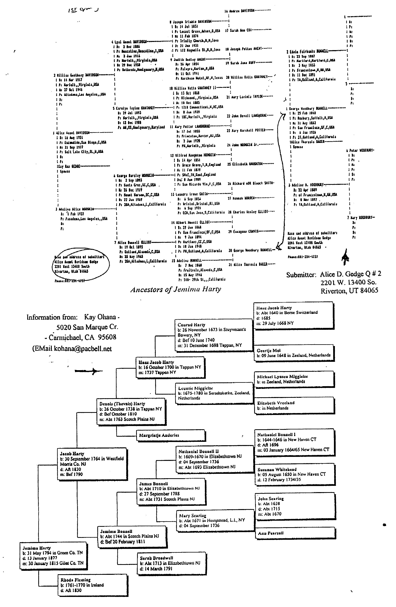
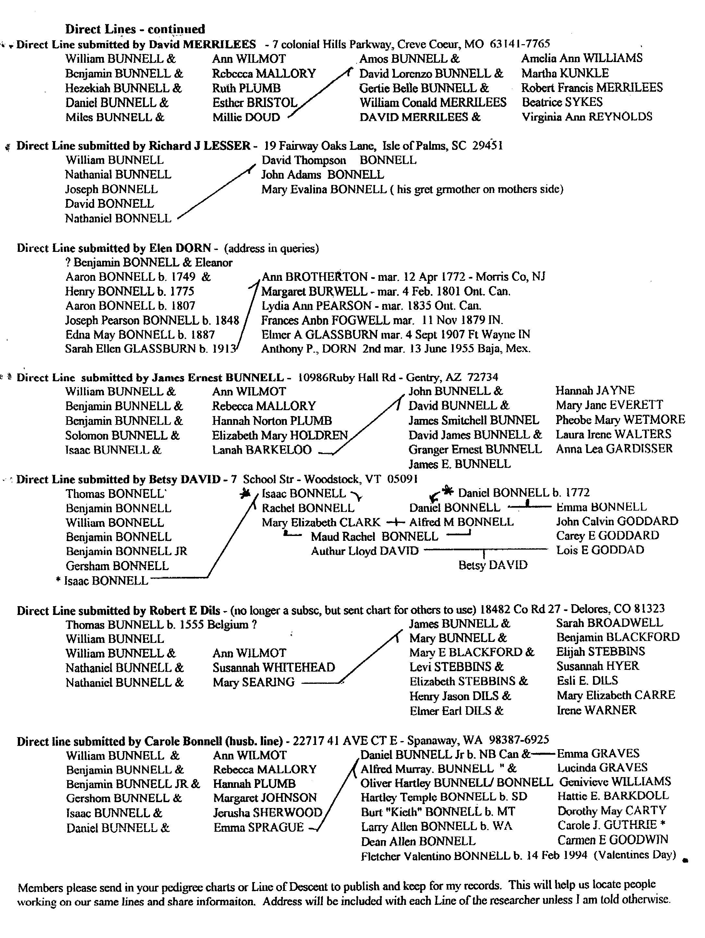
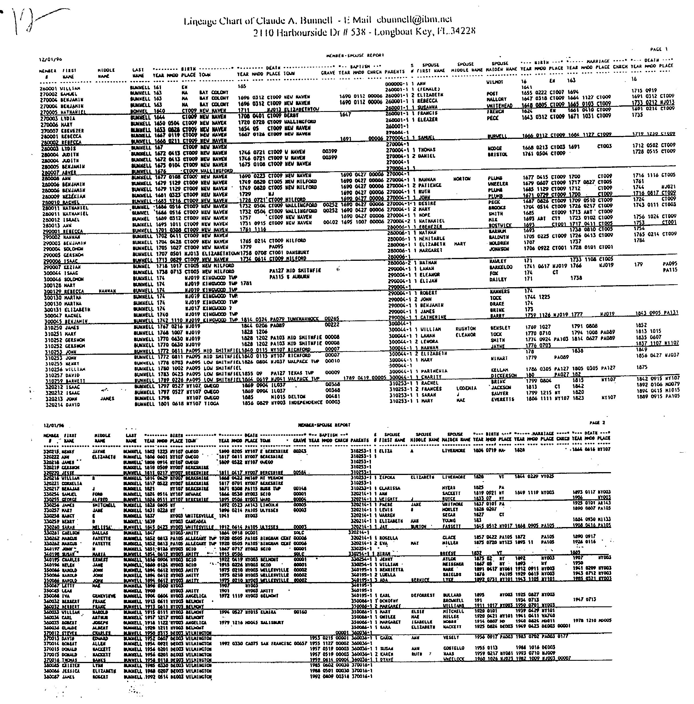

*** Newsletter Alert–Other ‘Family News’ publishers:
Be aware that Bath, Ohio is not the only ones advertising family history books, or newsletters that really are only computerized copies of general information with your surname inserted. I received a newsletter from an outfit in Greenwood Village, CO. They say inside the cover, after I got it, that many people had written saying “It is of little or no genealogical use.” The publishers Hope readers just have a sense of humor. They do offer a money back guarantee–so does Bath, Ohio (and this Fool did get her money back.)
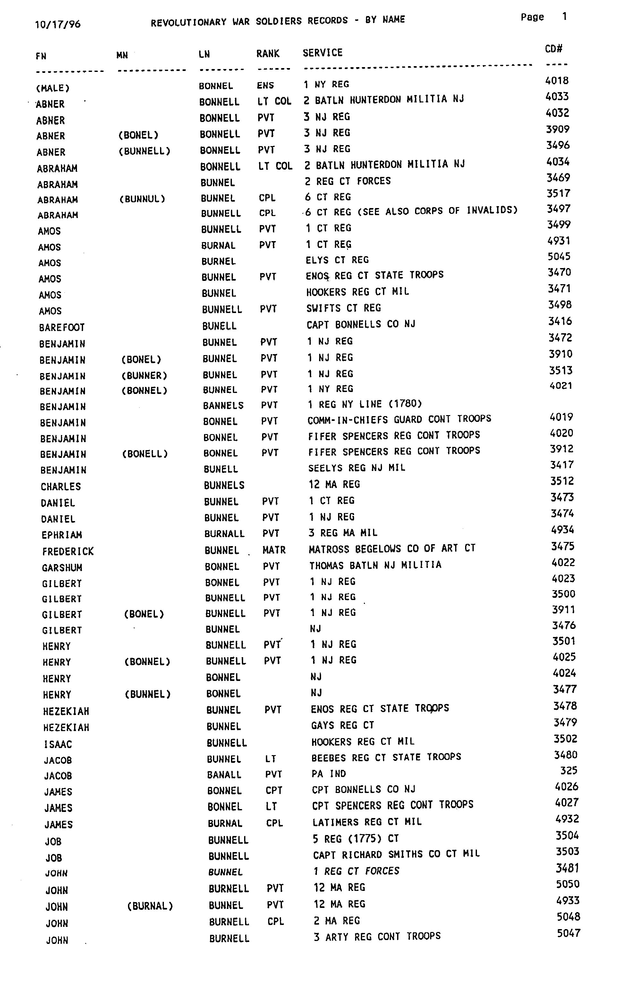
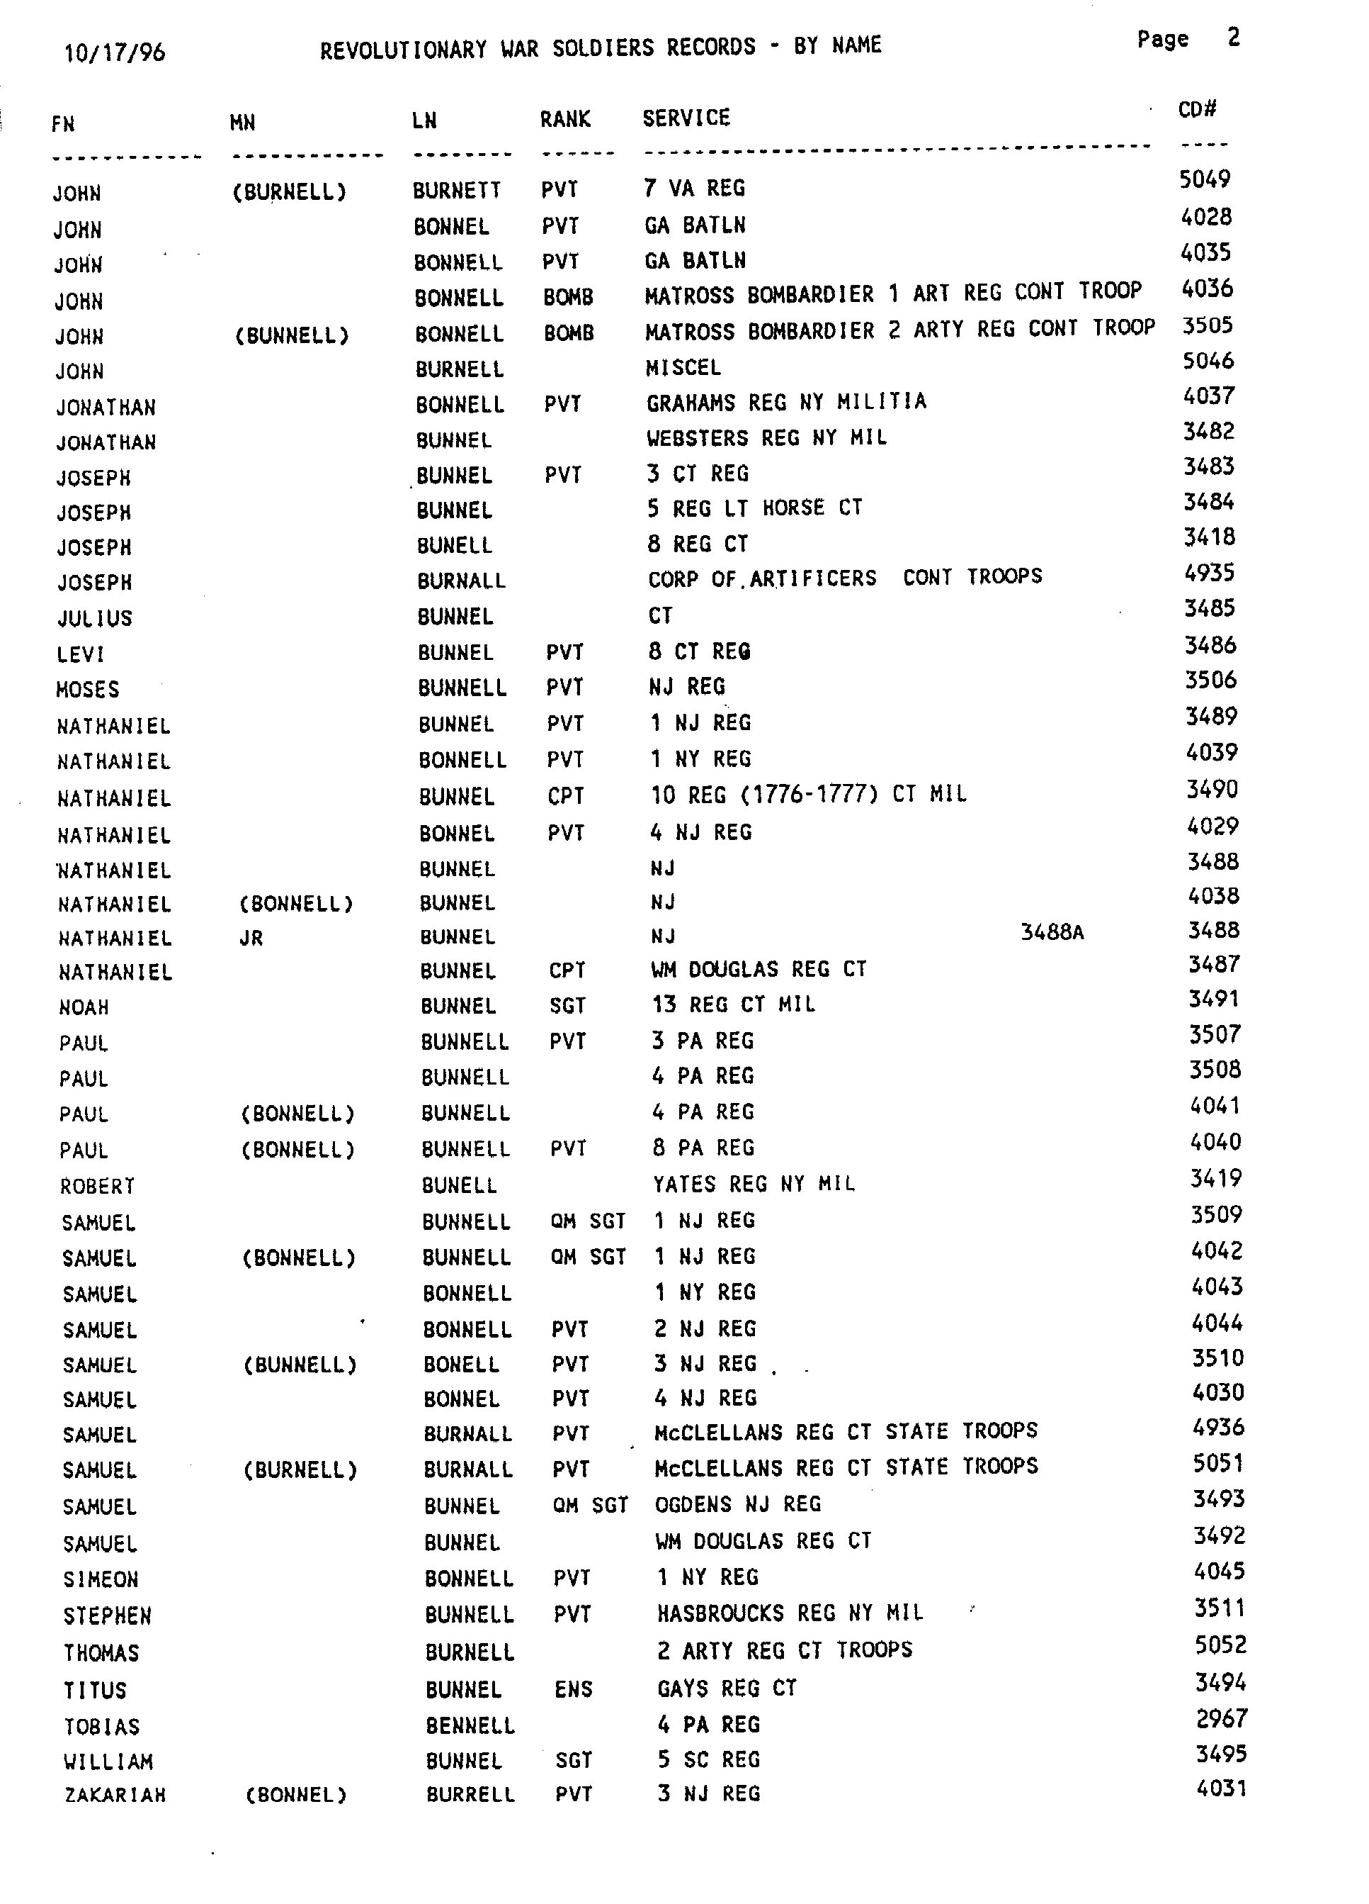
Charts from Claude A. Bunnell–2110 Harbourside Dr #538–Longboat Key, FL 34228
He may have related information on these subjects in his data base. If not, write the National Archives in MD for forms to order records: General Reference Branch (NNRG), National Archives and Records Admin. 7th and Pennsylvania Ave. NW, Washington D.D. 20408.

These are just a few of the pages of charts. We will print a few in each newsletter. If anyone gets too anxious to see the rest you may send the newsletter SASE and 10 cents a page for copies. Number of pages are in the “index of information Received.”
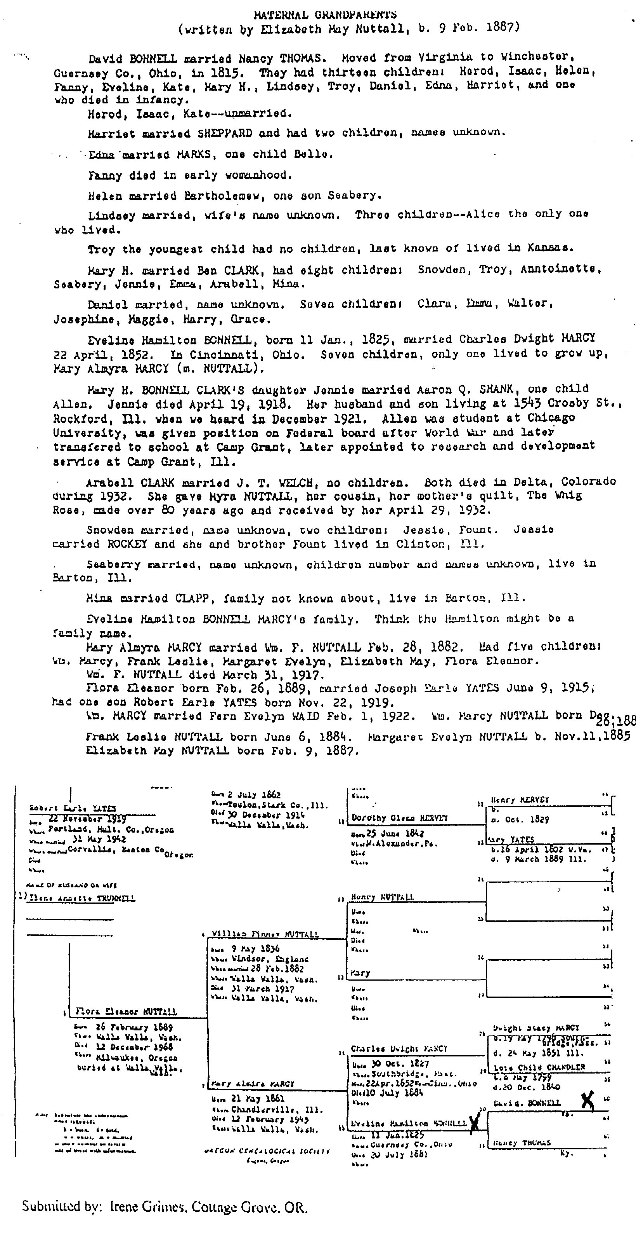
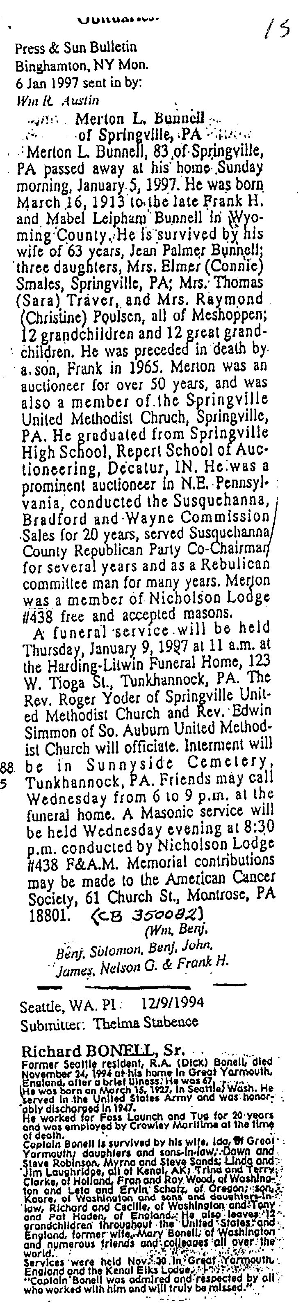

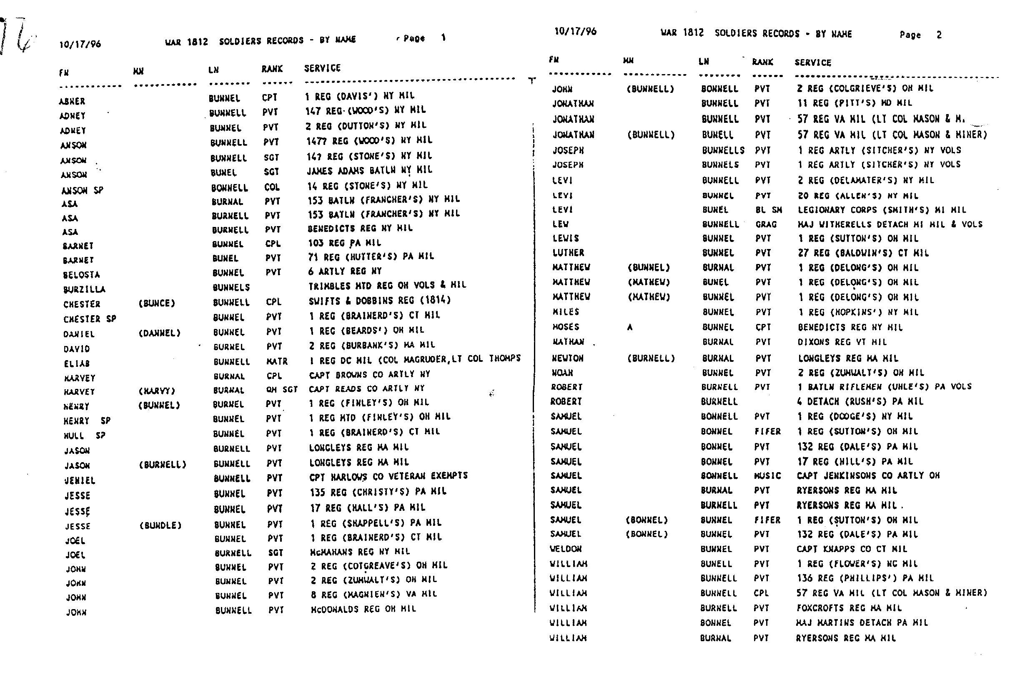
Bunnell - Bonnell Newsletter subscribers:

Well, here it is, our first issue as new editors. I thought long and hard about- doing this job, which was something I've wanted, but was worried if I could do as good a job as Wm Austin (Bless your heart) did. (The praise for his work on this has come in daily with subscription checks.) Teri finally convinced me by saying she would be glad and excited to help and if we didn't do it, it would cease to exist. How much worse could we do? So, now it's up to you to make it better.

As I sit completing the finishing touches on thbis, our first newsletter, I am reminded of the panic yesterday, 25 January, when I turned on my computer and found a black screen! Nothing worked. The newsletter was in the computer ready to print and I couldn't see it! I hadn't been 'smart' enough to back-up the work I had done, because I wasn't quite done - take heed - if you own a computer, they don't react to sweet talk or abusive words - I've tried both. They 'crash' when they feel like it and are stubborn as our ancestors could be.

I was so depressed, the first volume and I was already going to be late getting it out. Teri was giving me moral support and kept saying “We still have a few days, we can print the labels, address the envelopes and stamp them and hopefully…it will work soon.”

I called my son, Dean Bonnell and he took time off work and worked on it for three hours the next day. So he deserves a great big Bonnell thanks! I sure do appreciate him. I’m a computer dinosaur. I use one enough to depend on it, but know just enough to use ‘my’ programs, but the technical stuff baffles me. As you will see, I do not have the data or the knowledge as William Austin had to connect most people mentioned in the newsletter to our immigrant William Bunnell. Please be patient. To end hopefully, we will meet our deadline of the end of January to mail this. I hope you enjoy it and will add to it in the future.

So Thank you, Teri, and Dean Bonnell, and Claude Bunnell for all their help and William Austin for giving me the chance to carry on the newsletter. I couldn’t have done it without you!

(any newsletter subscribers, who wrote wanting the newsletter and would pay later will have on their address label (97 UNPD). Please send check as soon as possible. Thanks.)

Carole Bonnell

